**CSS**

# seletor de id.

. seletor de classe

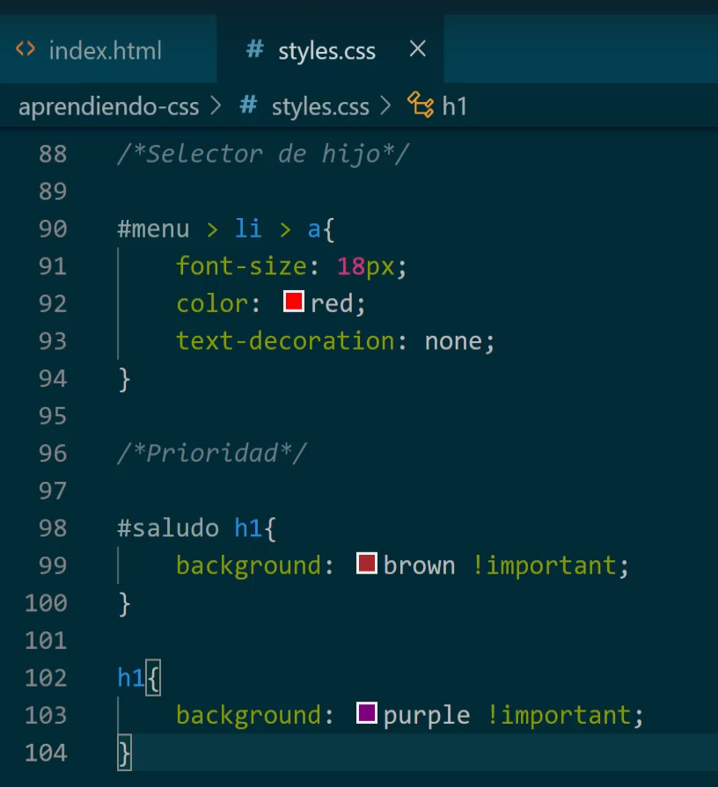

A prioridade é definida pela ordem. O que vem por último prevalece. Exceto, se o anterior forma mais específico, ou se contiver a cláusula *!important.*

#menu > li > a → tem que ser exatamente esta sequência.

#menu a → qualquer ***a*** debaixo de ***menu.***

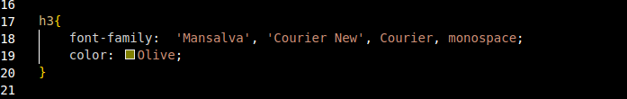

***Busca a primera fonte, se não encontrar busca a próxima.***

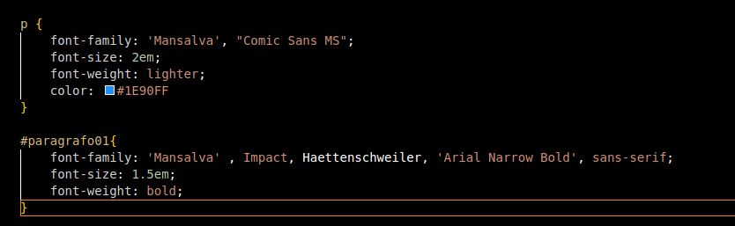

***font-weight → bold***

***https://fonts.google.com/***

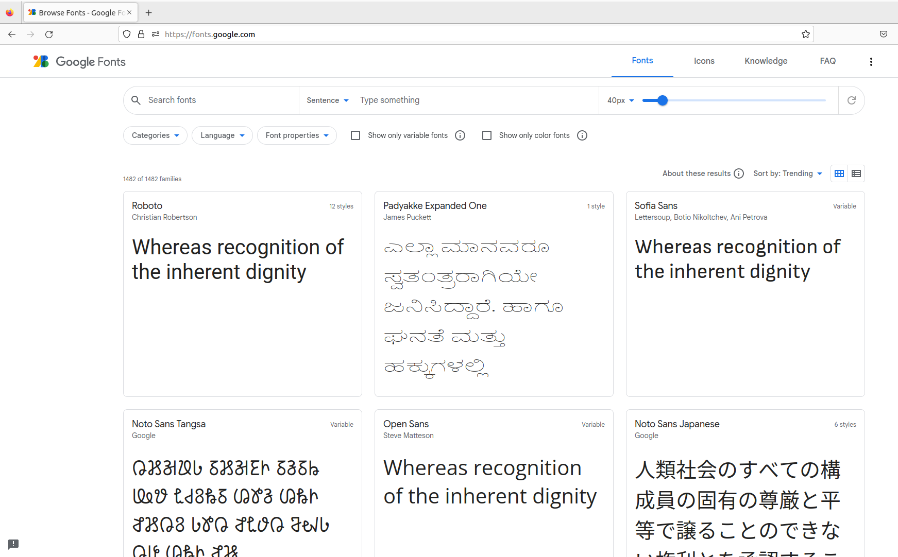

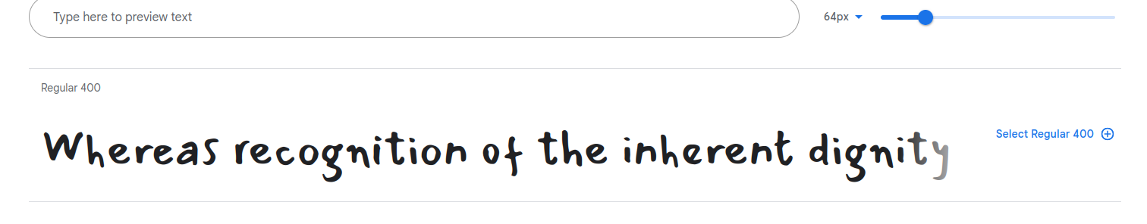

***Clicar em “Select Regular 400”***

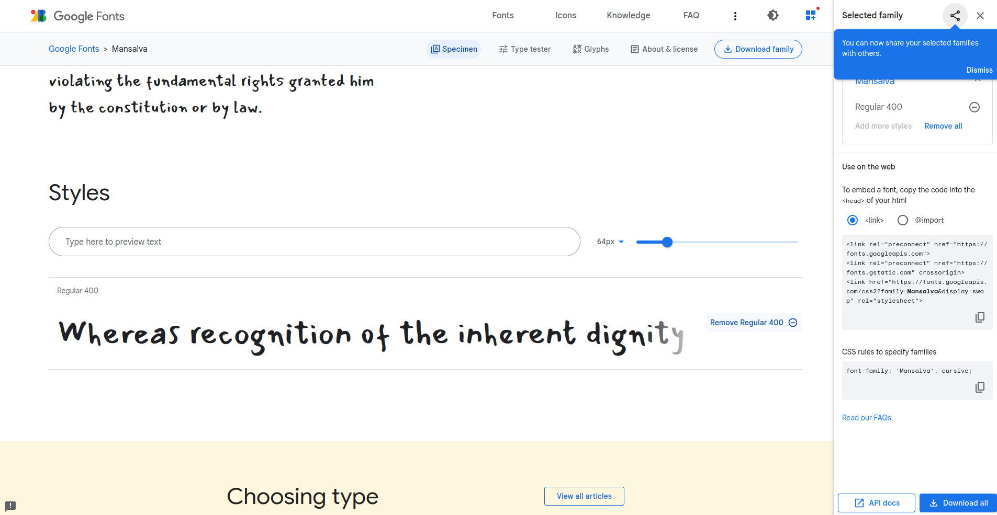

***import font***

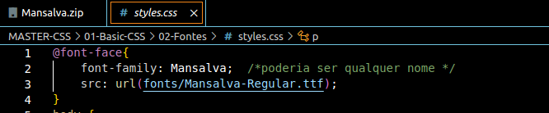

**ou**

**de um arq1uivo local**

**ou**

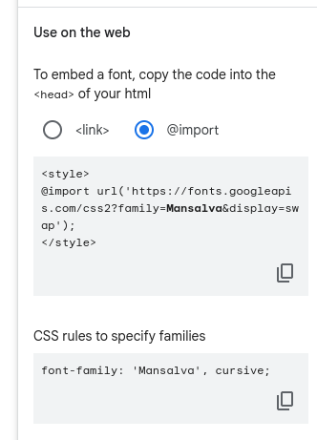

<https://www.toptal.com/developers/css3maker>

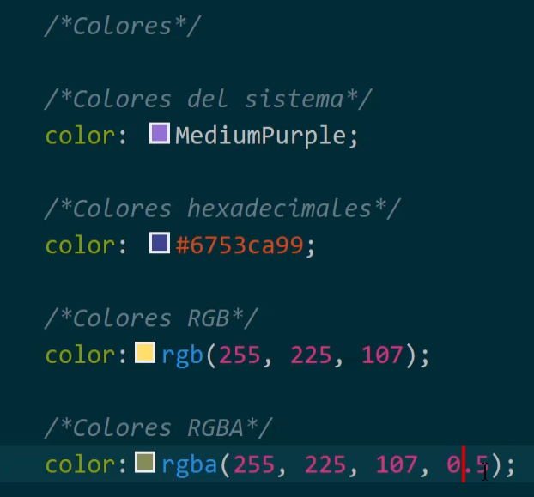

Quarto parâmetro → Transparência

<https://htmlcolorcodes.com/color-picker/>

BACKGROUND

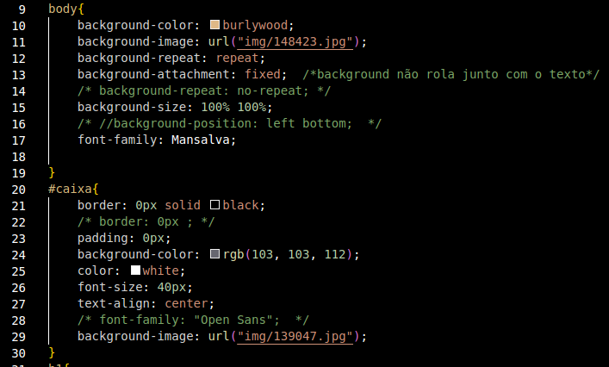

background-repeat: repeat-x;

background-repeat: repeat-y;

Resultados:

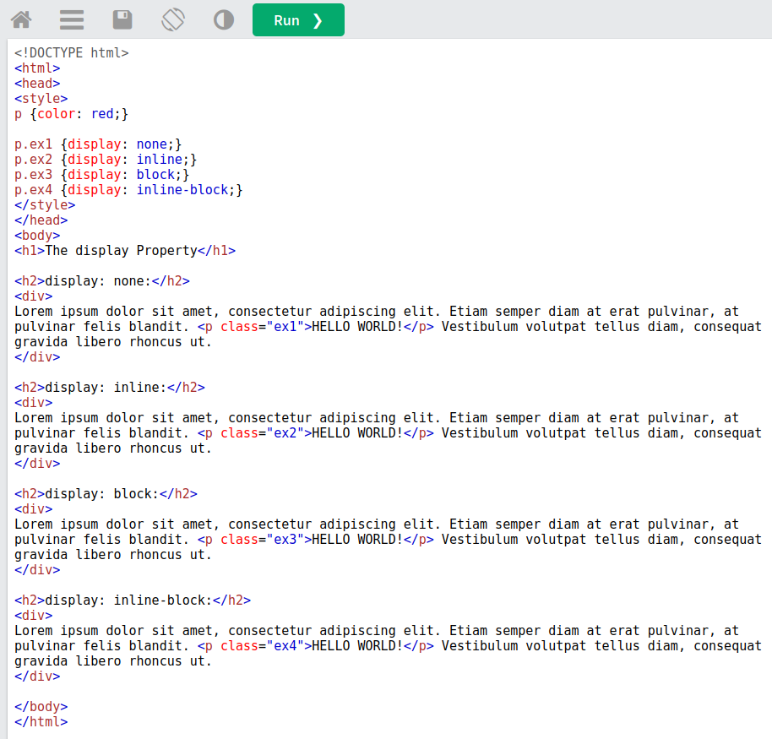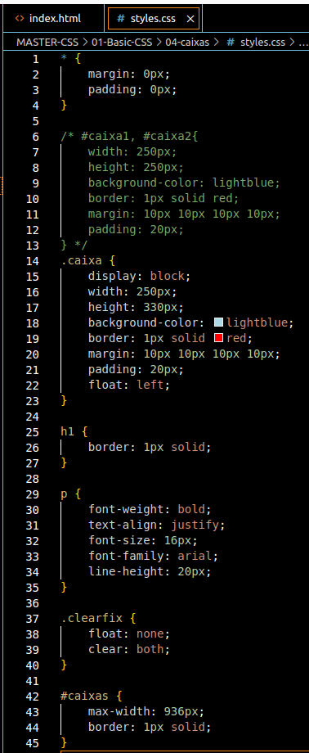

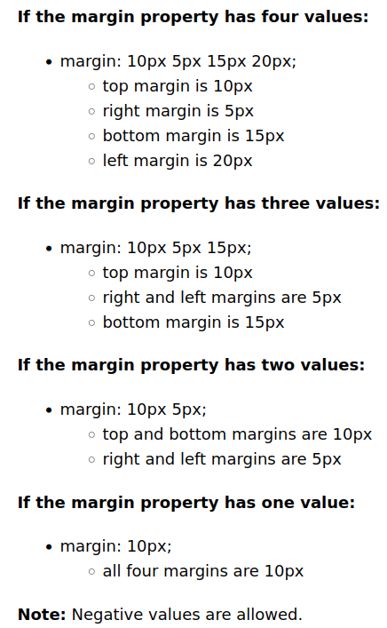

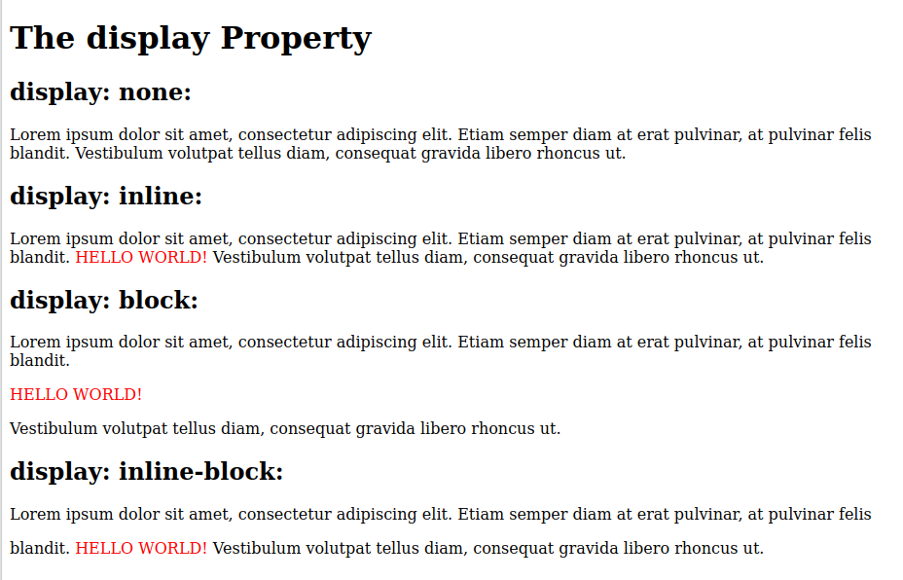

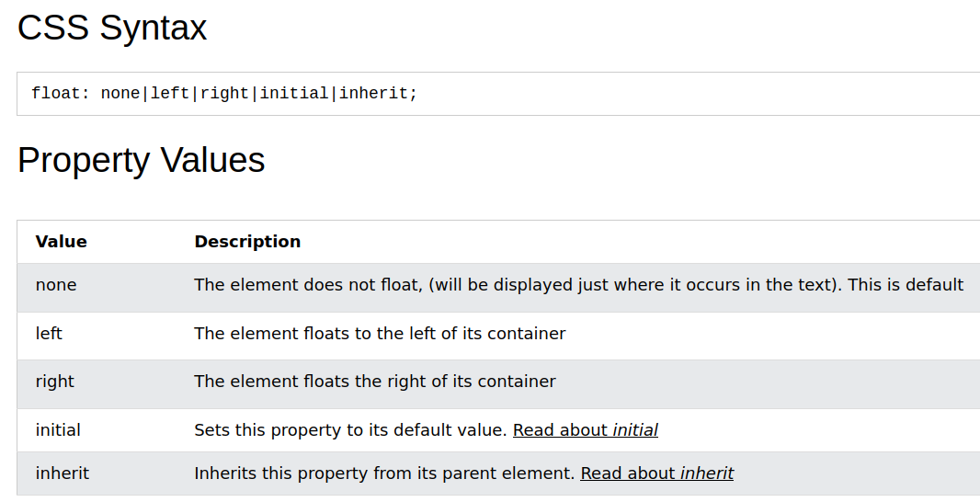

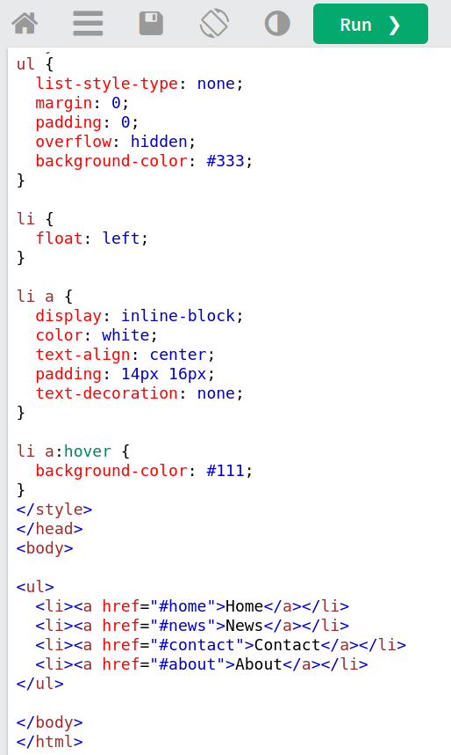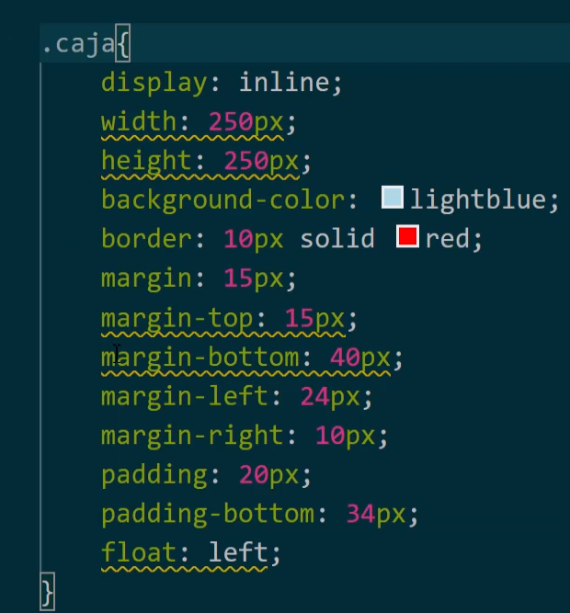

Resultado:

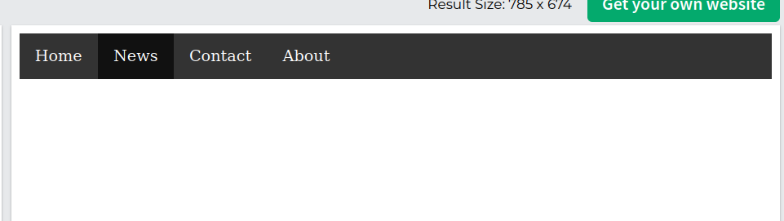

**ATENÇÃO: Se display não é block, as propriedades sublinhadas na imagem abaixo não podem ser aplicadas:**

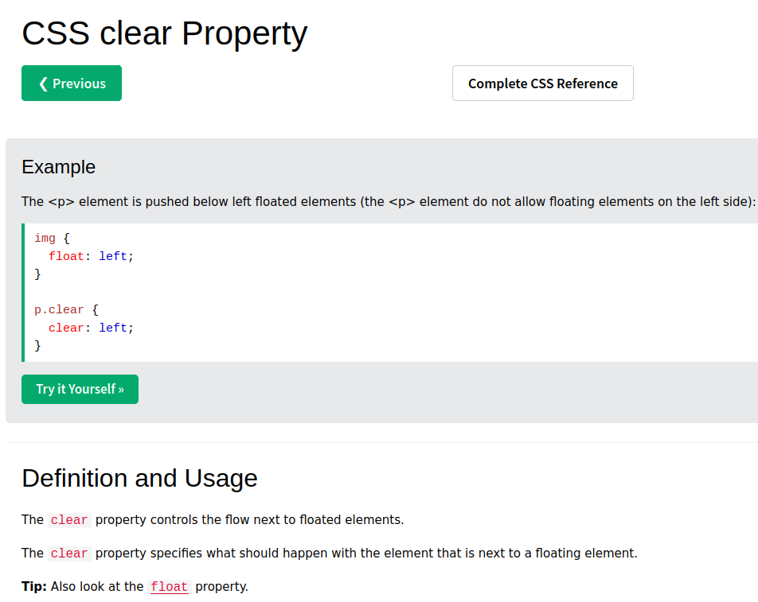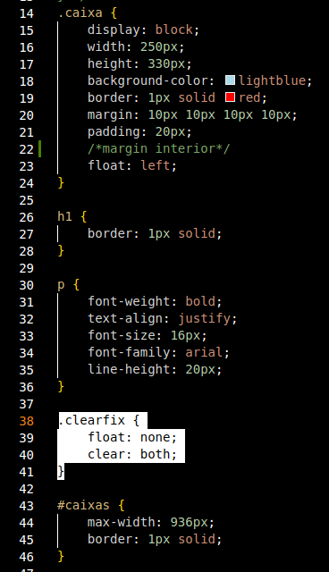

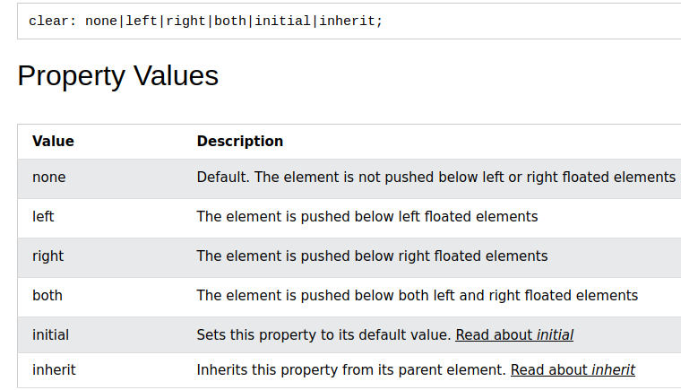

Depois de <div class="clearfix"></div> os objetos não estão mais controlados pelo float.

Atenção para a propriedade max-width

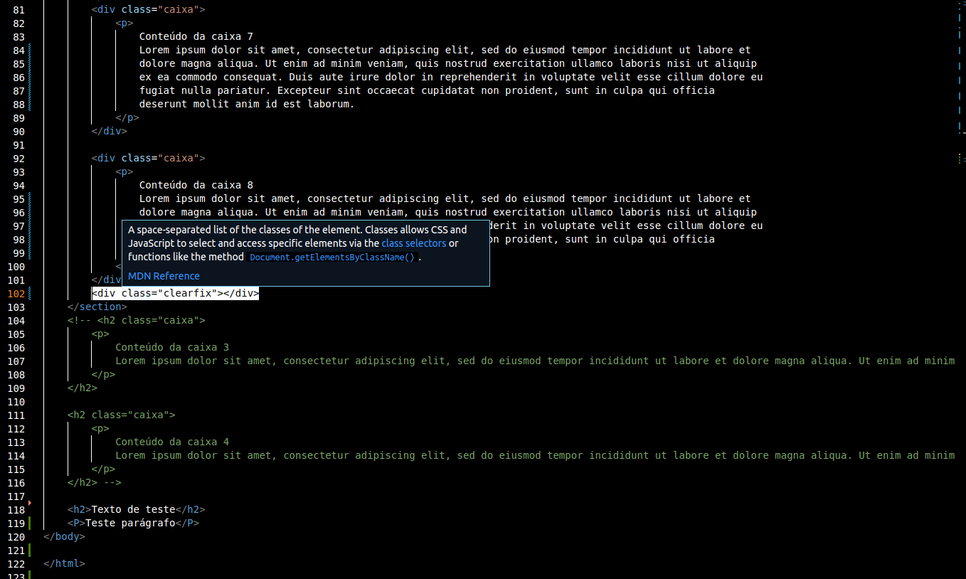

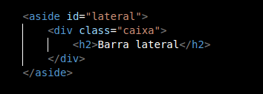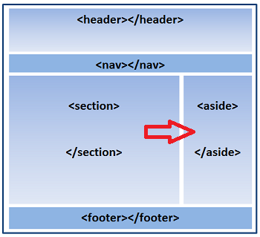

aside, do HTML5 é uma barra lateral

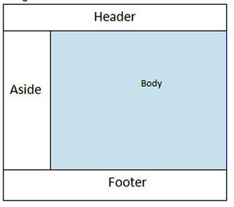

The <aside> tag defines some content aside from the content it is placed in.

The aside content should be indirectly related to the surrounding content.

**Tip:** The <aside> content is often placed as a sidebar in a document.

Note: The <aside> element does not render as anything special in a browser. However, you can use CSS to style the <aside> element

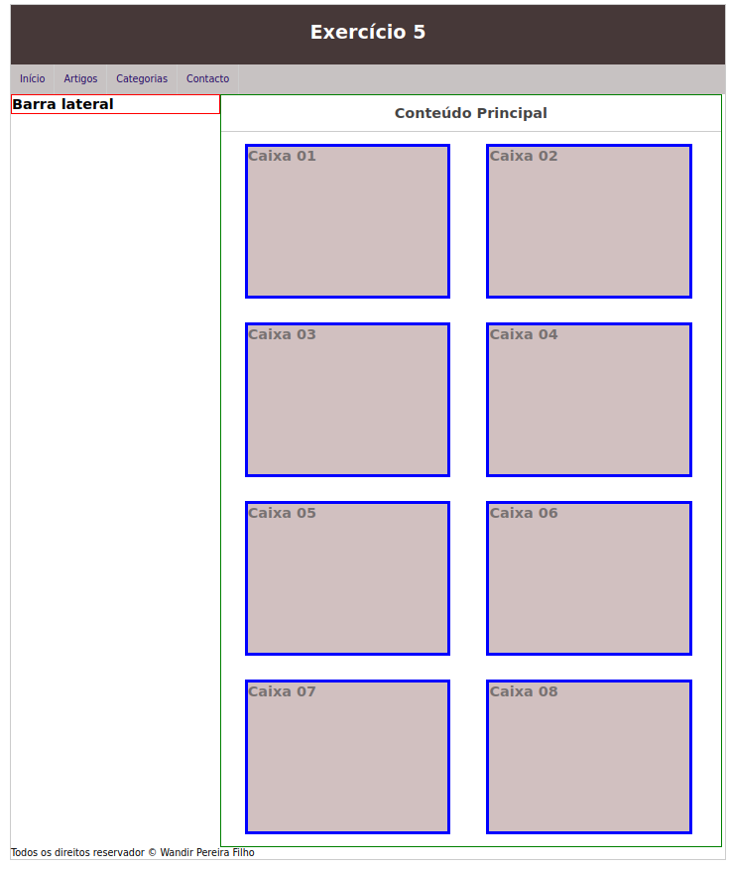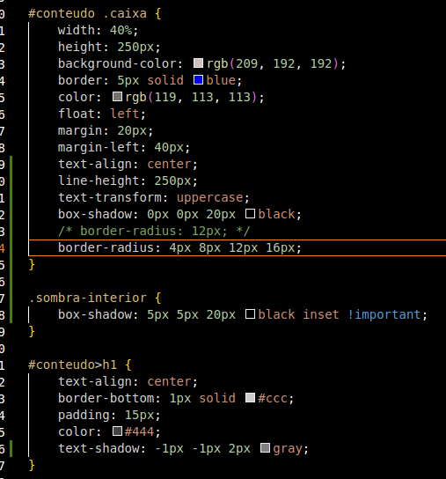

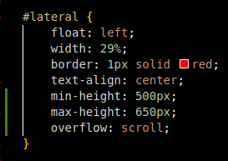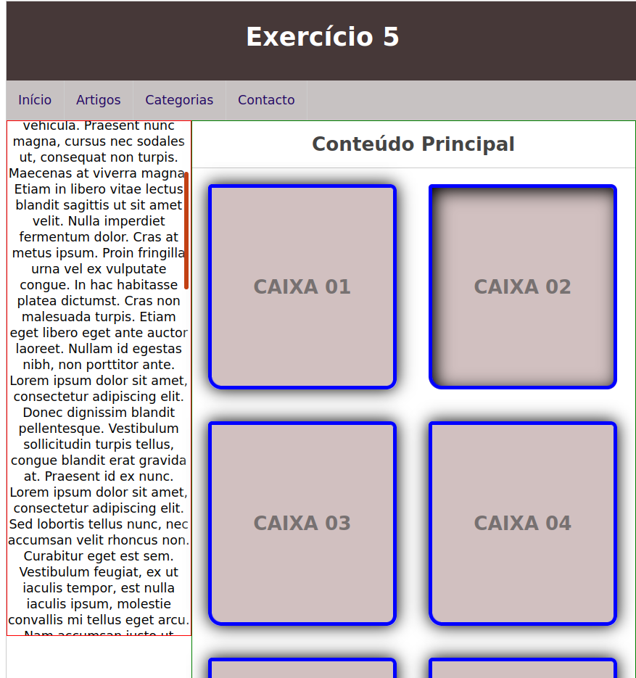

# CSS Layout - Overflow

The CSS overflow property controls what happens to content that is too big to fit into an area.

The overflow property specifies whether to clip the content or to add scrollbars when the content of an element is too big to fit in the specified area.

The overflow property has the following values:

* visible - Default. The overflow is not clipped. The content renders outside the element's box
* hidden - The overflow is clipped, and the rest of the content will be invisible
* scroll - The overflow is clipped, and a scrollbar is added to see the rest of the content
* auto - Similar to scroll, but it adds scrollbars only when necessary

**Note:** The overflow property only works for block elements with a specified height.

Note: In OS X Lion (on Mac), scrollbars are hidden by default and only shown when being used (even though "overflow:scroll" is set).

## overflow-x and overflow-y

The overflow-x and overflow-y properties specifies whether to change the overflow of content just horizontally or vertically (or both):

overflow-x specifies what to do with the left/right edges of the content.  
overflow-y specifies what to do with the top/bottom edges of the content.

**z-index**

The z-index property specifies the stack order of an element.

An element with greater stack order is always in front of an element with a lower stack order.

**Note:** z-index only works on positioned elements (position: absolute, position: relative, position: fixed, or position: sticky) and flex items (elements that are direct children of [display:flex](https://www.w3schools.com/cssref/pr_class_display.php) elements).

Note: If two positioned elements overlap without a z-index specified, the element positioned last in the HTML code will be shown on top.

| Default value: | auto |
| --- | --- |
| Inherited: | no |
| Animatable: | yes. [Read about animatable](https://www.w3schools.com/cssref/css_animatable.php) |

| Version: | CSS2 |
| --- | --- |
| JavaScript syntax: | *object*.style.zIndex="-1" |

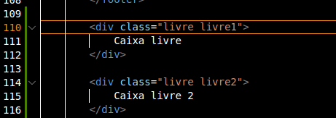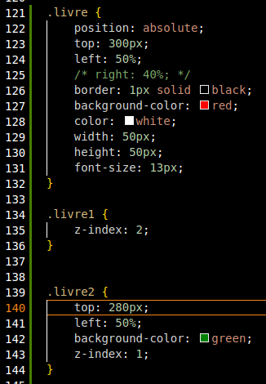

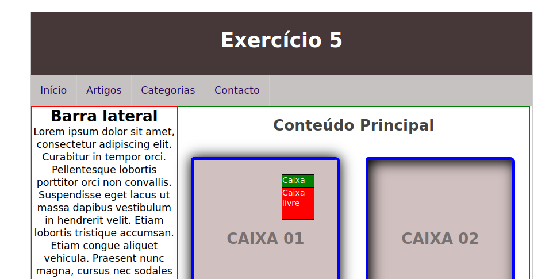

POSITION

## The position Property

The position property specifies the type of positioning method used for an element.

There are five different position values:

* static
* relative
* fixed
* absolute
* sticky

Elements are then positioned using the top, bottom, left, and right properties. However, these properties will not work unless the position property is set first. They also work differently depending on the position value.

**RELATIVE** → DEFAULT

**ABSOLUTE** → DEFINE AS COORDENADAS ONDE O OBJETO DEVE FICA NA TELA. Move JUNTAMENTE COM O ROLAR DA TELA.

**FIXA** – A TELA PODE MOVER, MAS OBJETO NÃO MOVE. Fixa FIXO NO MESMO LUGAR.

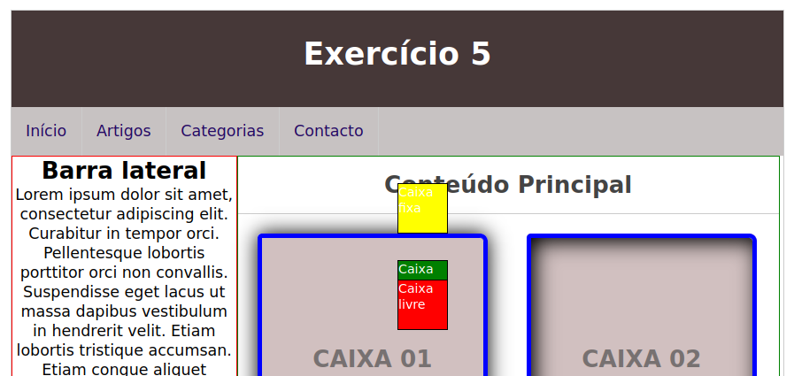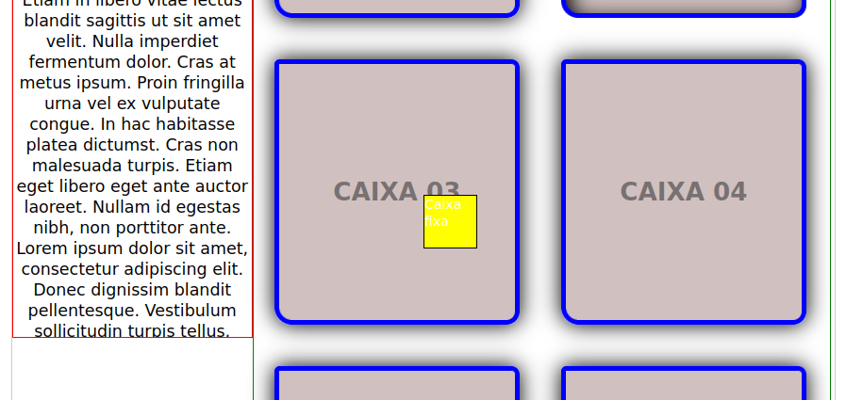

***************************************************************************************************************

Extensions VC Code

* Prettier - Code Fornatter
* Color HighLight

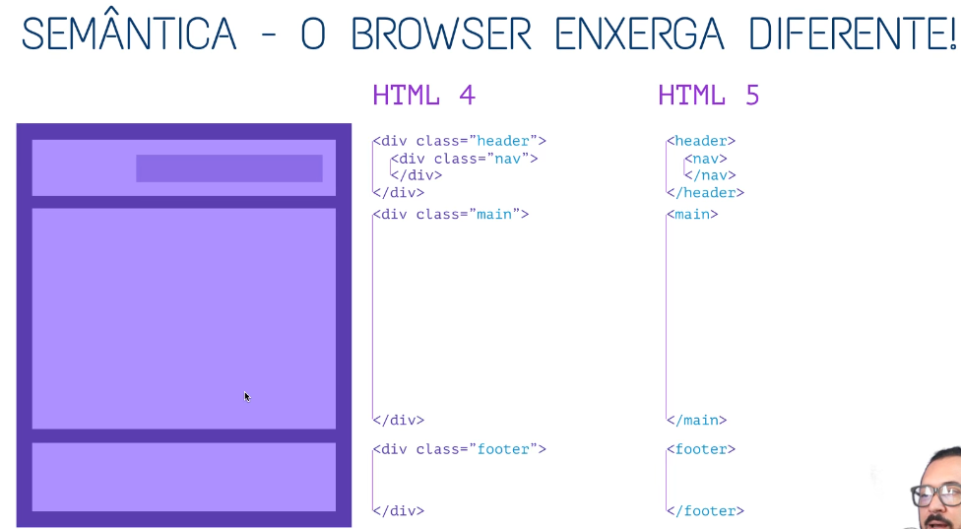

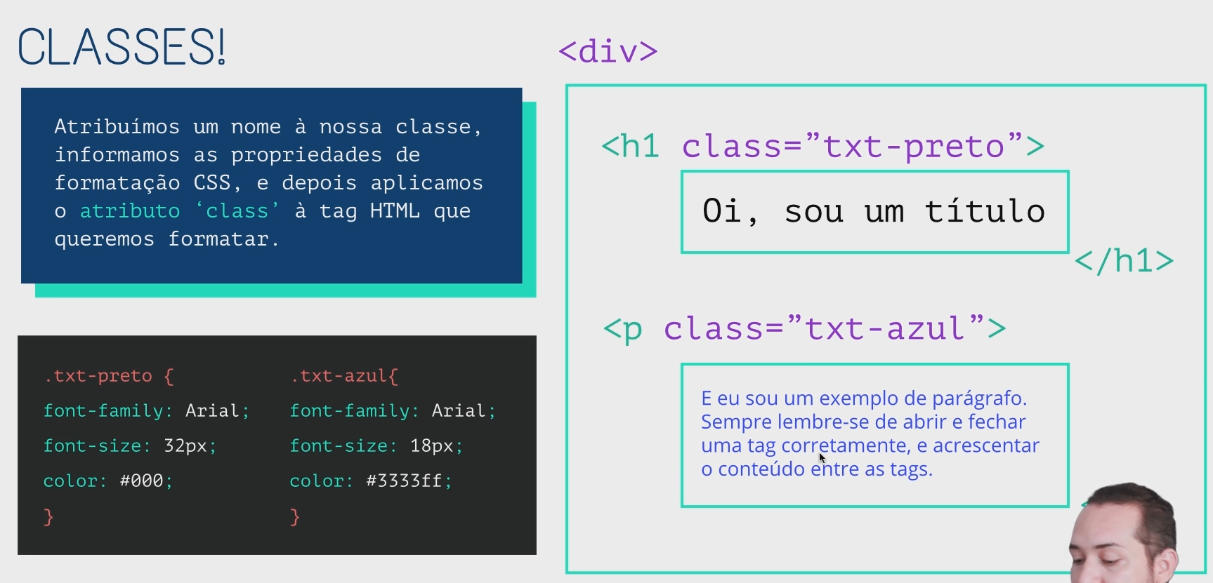

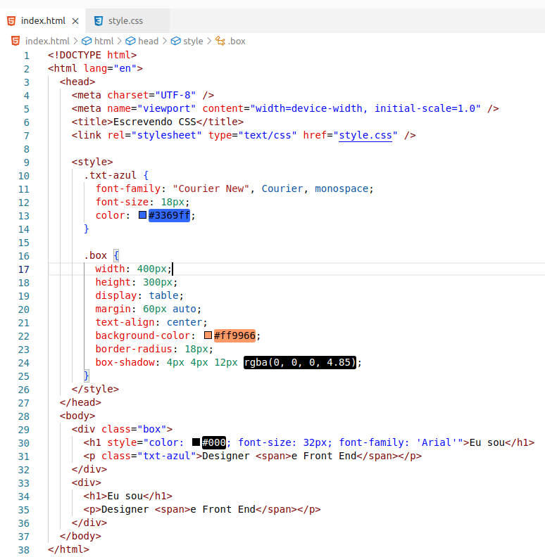

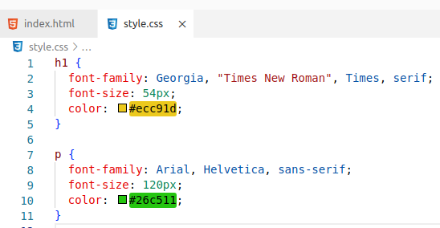

There are several rules ( applied in this order ) :

1. inline css ( html style attribute ) overrides css rules in style tag and css file
2. a more specific selector takes precedence over a less specific one
3. rules that appear later in the code override earlier rules if both have the same specificity.
4. A css rule with !important always takes precedence.

In your case its rule 3 that applies.

Specificity for single selectors from highest to lowest:

* ids (example: #main selects <div id="main">)
* classes (ex.: .myclass), attribute selectors (ex.: [href=^https:]) and pseudo-classes (ex.: :hover)
* elements (ex.: div) and pseudo-elements (ex.: ::before)

To compare the specificity of two combined selectors, compare the number of occurences of single selectors of each of the specificity groups above.

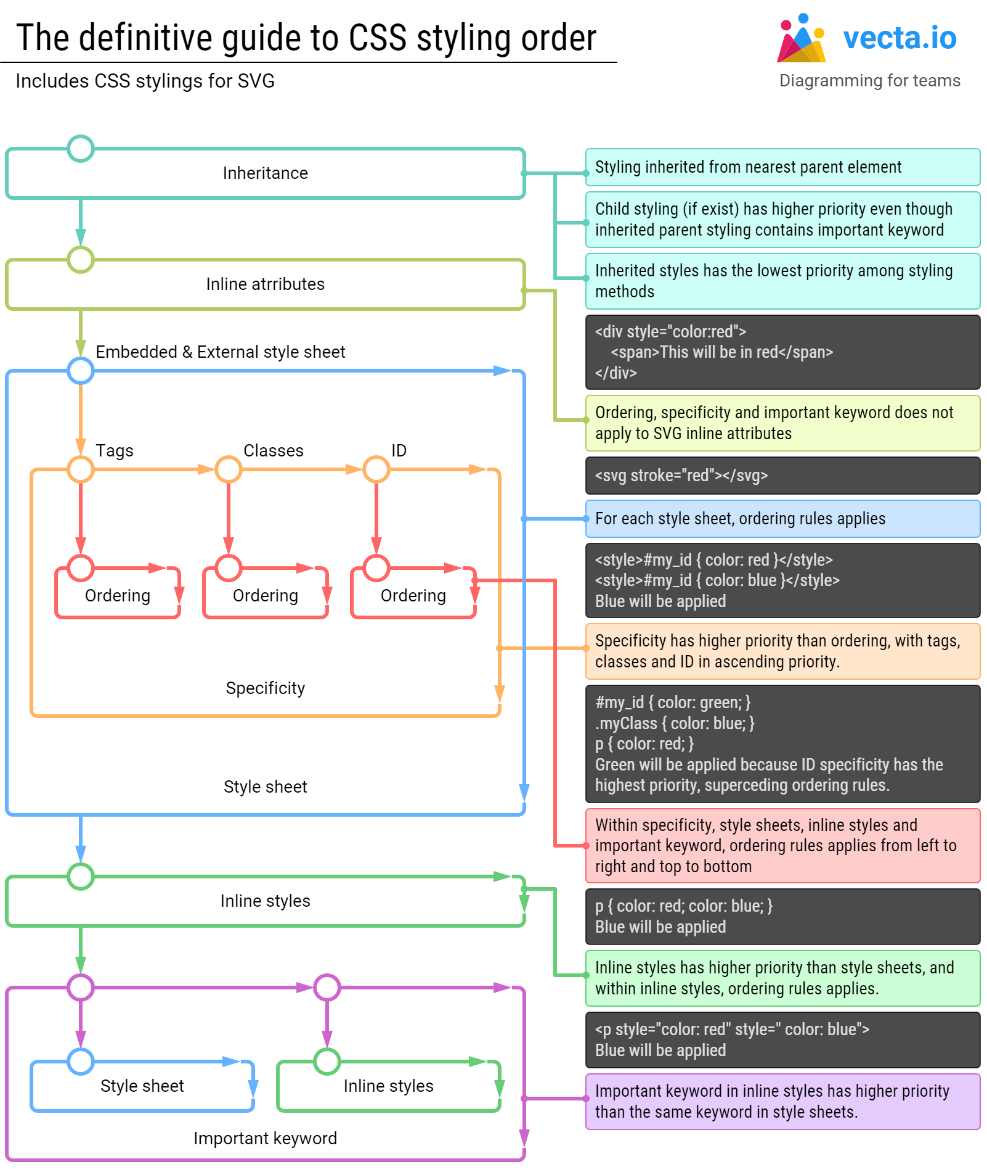

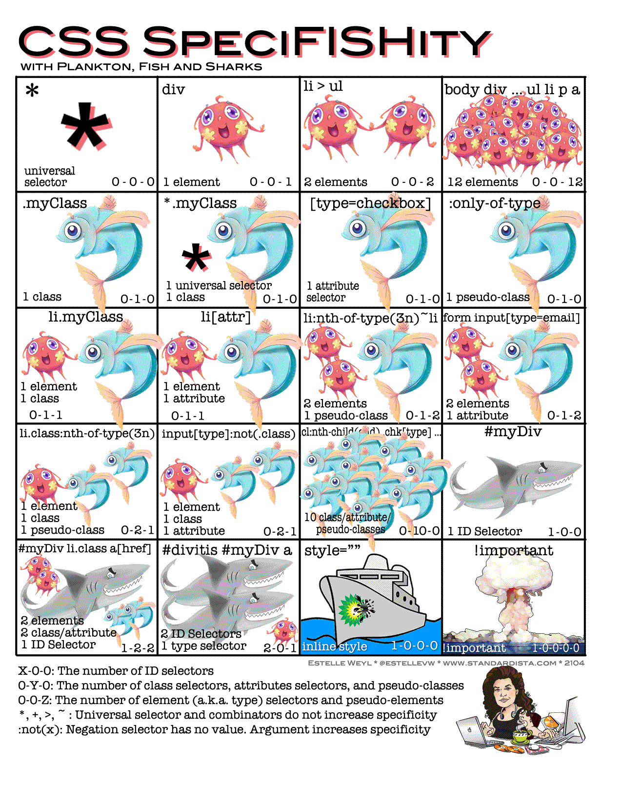

# CSS Selector’s priority

# <https://dev.to/one-beyond/css-selectors-priority-1cjh>

[#css](https://dev.to/t/css) [#webdev](https://dev.to/t/webdev) [#html](https://dev.to/t/html) [#beginners](https://dev.to/t/beginners)

Almost all the CSS style conflicts and style overrides have to do with the css selector's priority. In this article I will talk about how the css selector's priority works.

CSS selectors have a strict hierarchy. I have divided them into 6 levels (from 0 to 5).

**Level 0 :**

* [Universal selector](https://developer.mozilla.org/en-US/docs/Web/CSS/Universal_selectors) *

* { color: #000 }

* [CSS combinators](https://developer.mozilla.org/en-US/docs/Web/CSS/CSS_Selectors#combinators), such as adjacent sibling selector +, child selector >, general sibling selector ~, descendant selector space

div + div { padding: 8px; }

div > p { text-decoration: underline; }

p ~ p { margin-bottom: 8px; }

header h1 { font-size: 18px; }

* [Logic pseudo-class](https://developer.mozilla.org/en-US/docs/Web/CSS/Pseudo-classes), such as :not(), :is(), :where() , these logic pseudo classes won't affect the priority, what will affect the priority is the selectors that pass to the pseudo-class function. Pay attention that here I only list the logic pseudo class, not including the other non-logic pseudo class, such as :hover, :first-child etc.

p:not(.text) { color: red; }

div:is(li) {font-size: 8px; }

main:where(h1, h2, h3) { color: orange; }

**Level 1:**

* [Type selector](https://developer.mozilla.org/en-US/docs/Web/CSS/Type_selectors), such as p div header span

header { color: #fff }

p { background: red }

**Level 2:**

* [Class selector](https://developer.mozilla.org/en-US/docs/Web/CSS/Class_selectors) .className

.text { color: red }

* [attribute selector](https://developer.mozilla.org/en-US/docs/Web/CSS/Attribute_selectors) [attribute]

[data-text] { color: blue }

* [pseudo class](https://developer.mozilla.org/en-US/docs/Web/CSS/Pseudo-classes) such as :hover :link

:hover { color: green }

* [pseudo-element](https://developer.mozilla.org/en-US/docs/Web/CSS/Pseudo-elements) such as :first-child:

:first-child {margin-left: 8px}

**Level 3**

* [ID selector](https://developer.mozilla.org/en-US/docs/Web/CSS/ID_selectors) #id

#text { color: #fff }

**Level 4**

* Inline style in html tag:

<p style= "color:#000" >some text<p/>

**Level 5**

* The key word !important

.text { color: #fff !important }

The key word !important has the highest priority, usually it’s used to override the javascript style, otherwise I don’t recommend using it, it will be difficult to maintain the code if we abuse the !important key word.

We can see that from 0 to 3 level is all about css selectors’ priority, it’s also the most important part. If we can fully understand it , it will be much easier for us to override the style using css selector.

Although now we know all the css selectors’ priority, it’s still very abstract for us to compare them when there are multiple selectors together. You may ask, how can we compare div .foo[bar] { color:#fff } with body > div p.foo { color: #000 } ?

Don’t worry, I’ll also explain how to calculate the css selectors’ priority with actual values. Let’s say if you encounter one **level 0** priority selector, then you add **0** value to the total priority , if you encounter one **level 1** priority selector, then you add **1** value to the total priority, if you encounter one **level 2** priority selector, then you add **10** value to the total priority, and finally if you encounter one **level 3** priority selector, you add **100** value to the total priority. In summary:

* Level 0: **+0**
* Level 1: **+1**
* Level 2: **+10**
* Level 3: **+100**

Let’s see some examples:

1. * > div {} : 1 general selector (**level 0**), 1 css combinator (**level 0**), 1 type selector (**level 1**), so the total value is **0 + 0 + 1 = 1**
2. div > p .text:not(.content): 2 type selector (**level 1**), 1 *css combinator* (**level 0**), 2 *class selector* (**level 2**), 1 logic pseudo-class (**level 0**), so the total value is **2 * 1 + 0 + 2 * 10 + 0 = 22**
3. p[content="story"]: 1 type selector (**level 1**), 1 attribute selector (**level 2**), so the total value is **1+ 10 = 11**
4. #list > ol: 1 id selector (**level 3**), 1 css combinator (**level 0**), 1 type selector (**level 1**), so the total value is **100 + 0 + 1 = 101**

That’s how you calculate the priority value in css. Now you may ask what if I add 11 type selector, then the value is 11, so can it override one class selector, which has a value 10 ? The truth is the value here is only symbolic, I use 1, 10 ,100 here because no one will really use 10 selectors in the code, and the real fact is that the lower priority level selector can’t ever override the higher priority level. So even if you have 100 type selectors, you can’t override even one class selector.

If you happen to write 2 sets of selectors to target one element, and they have the same priority value, then the subsequent selectors will override the previous one. That’s how css is rendered in the web.

And that’s all you have to know about the css selectors’ priority.

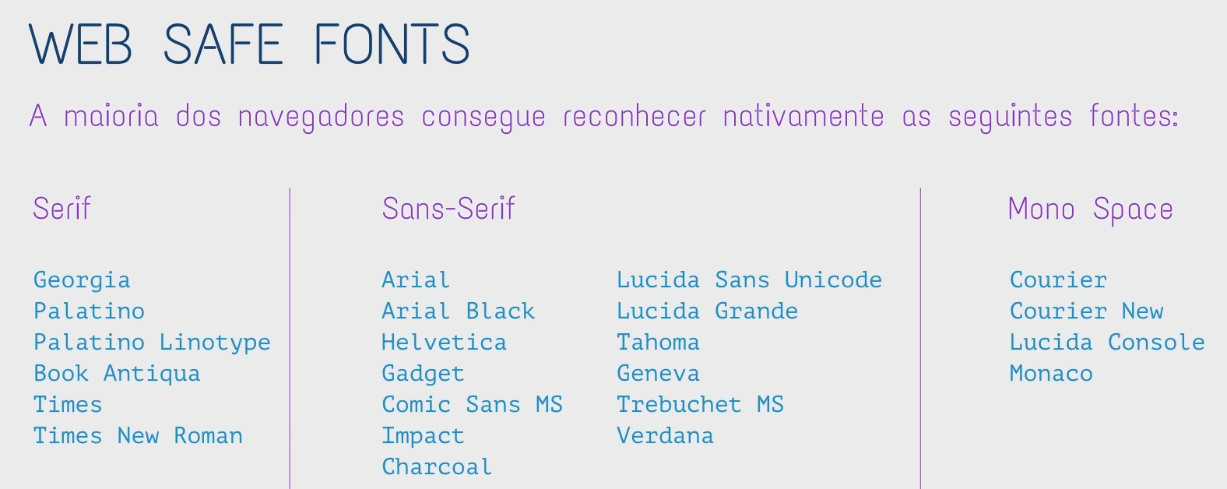

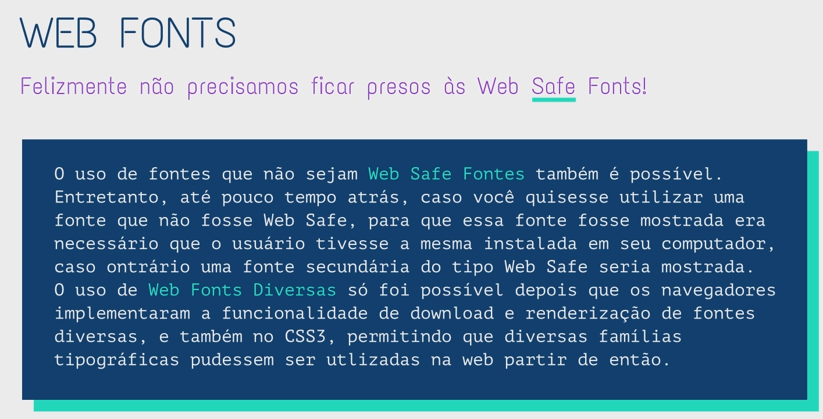

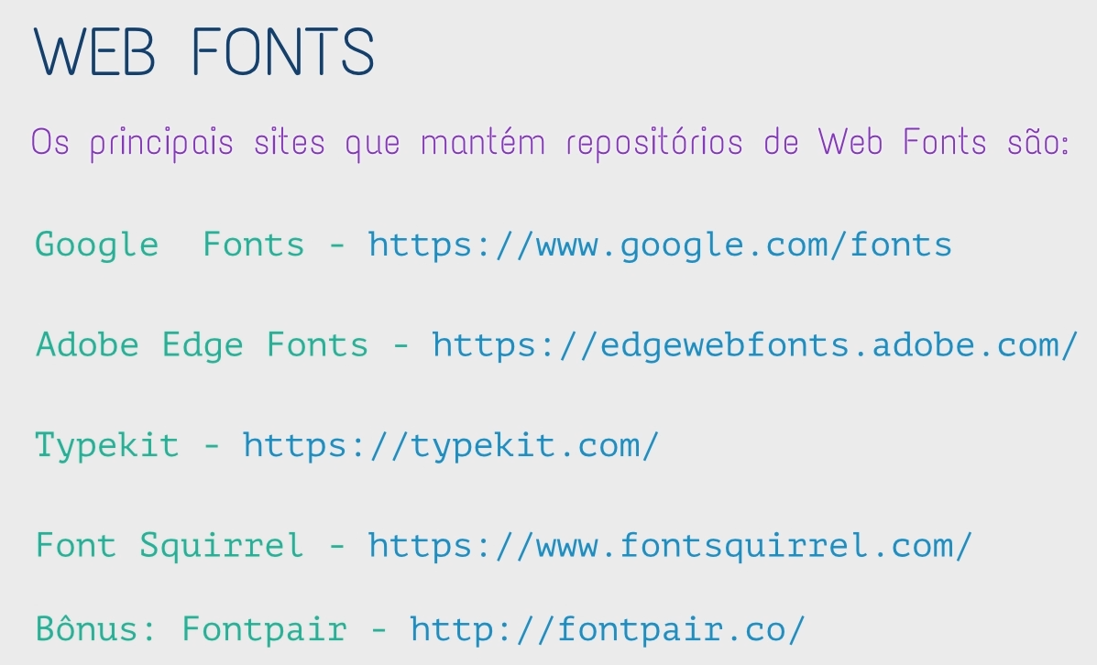

Ir no <https://www.dafont.com/pt/> --> escolher a fonte e baixar.

Ir no <https://www.fontsquirrel.com/tools/webfont-generator> --> upload fonts --> convert pacote compatível html --> Download your kit --> usar no

fontpair --> sugere combinação de fonts



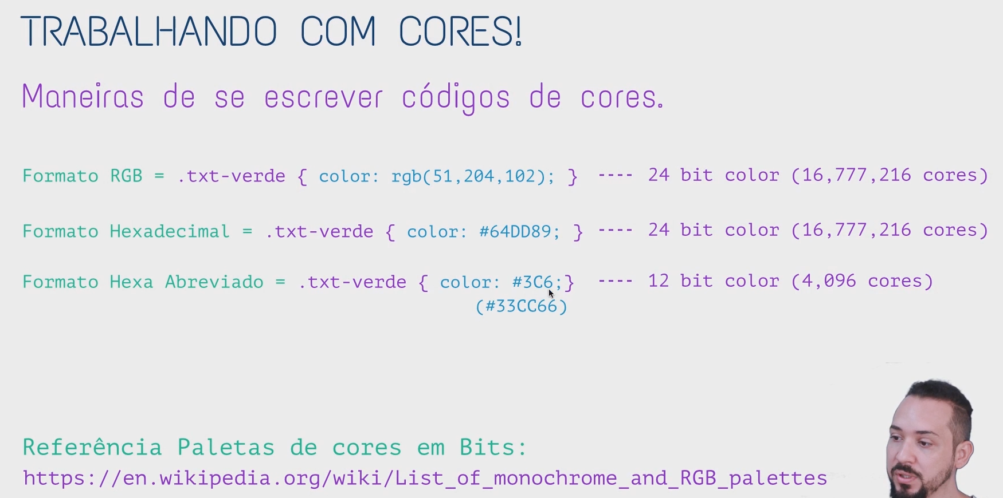

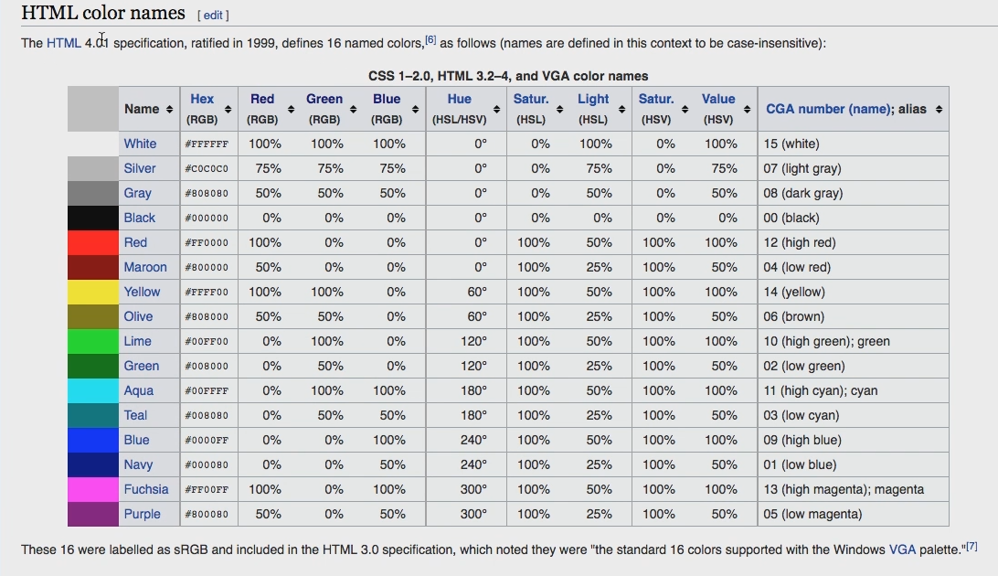

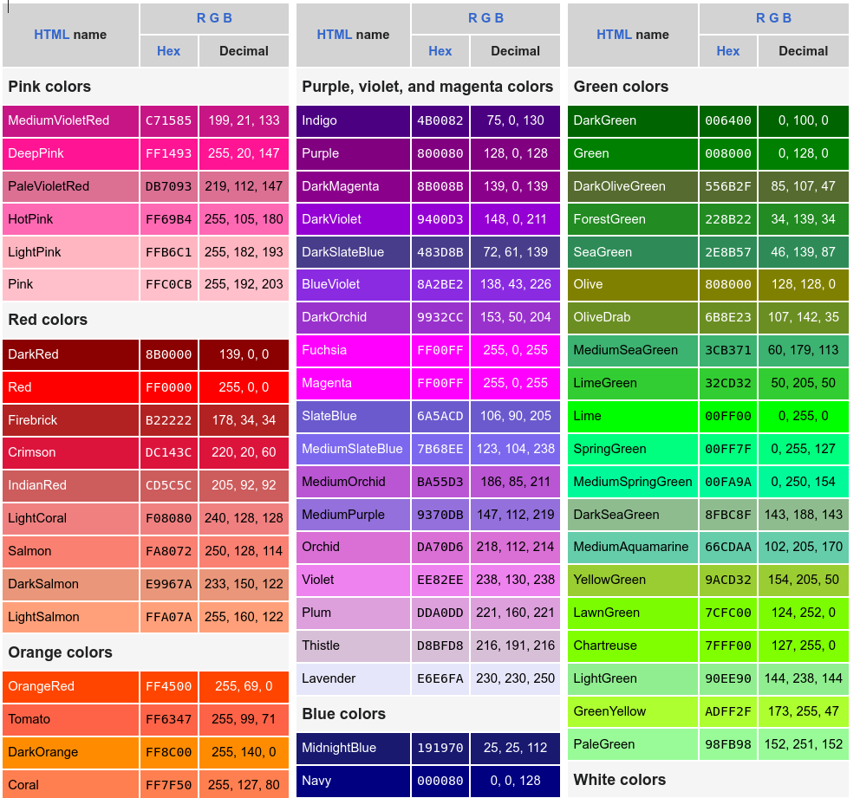

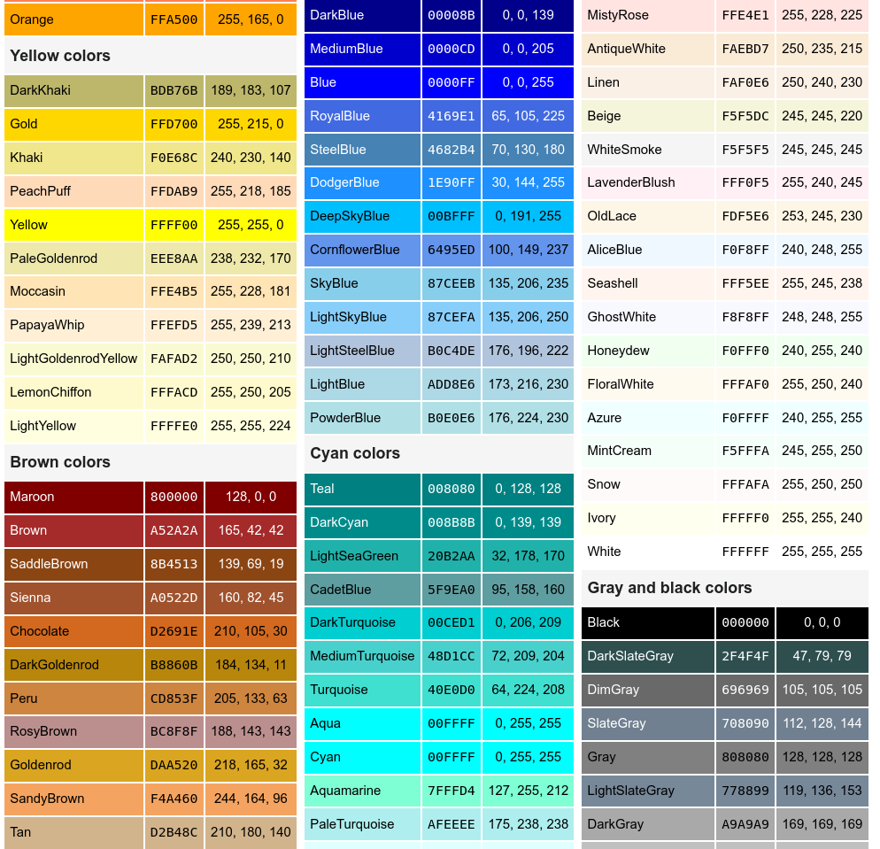

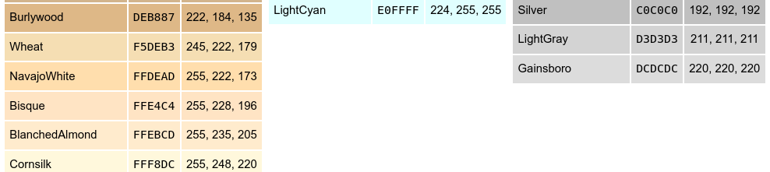

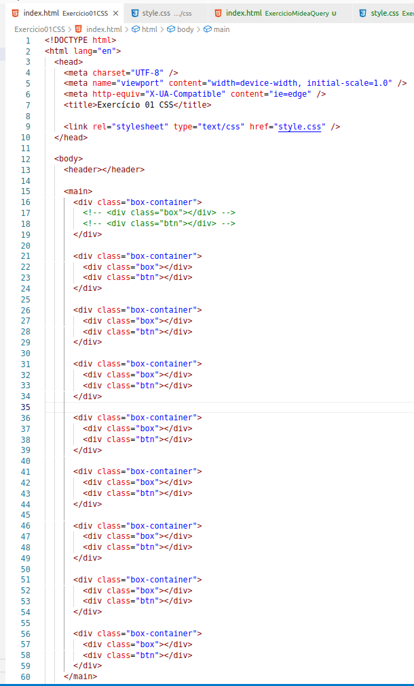

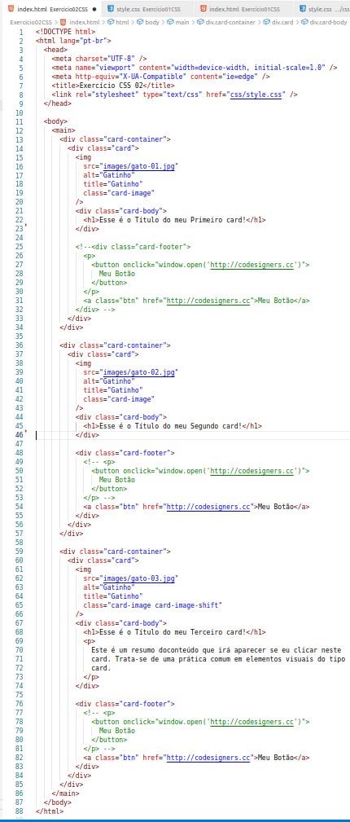

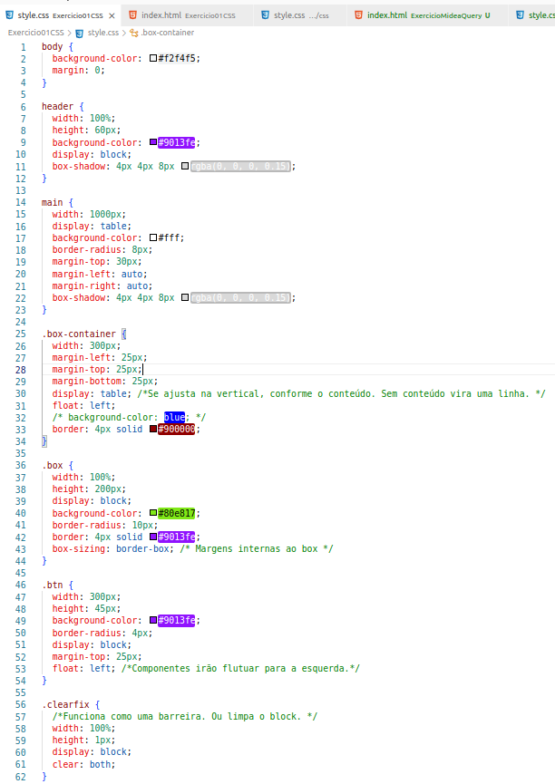

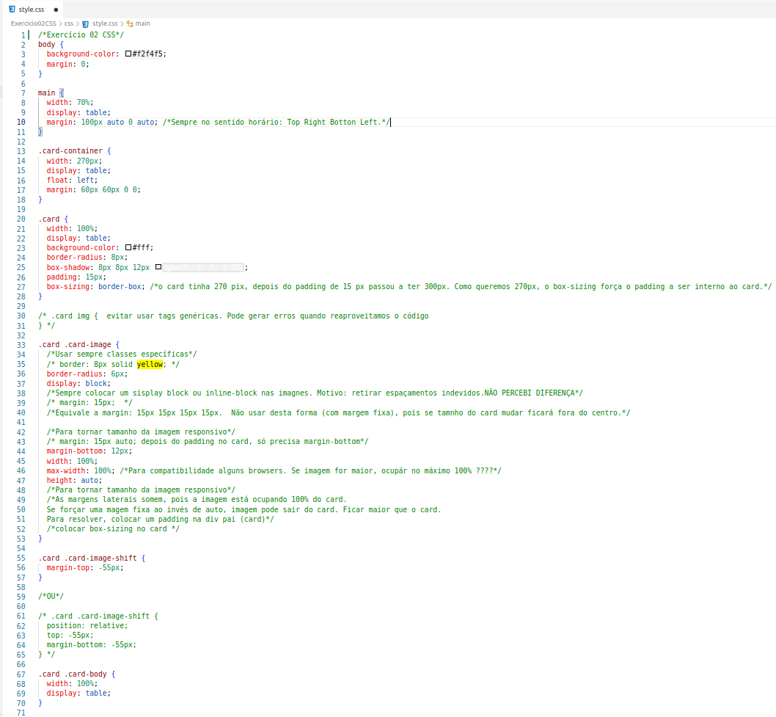

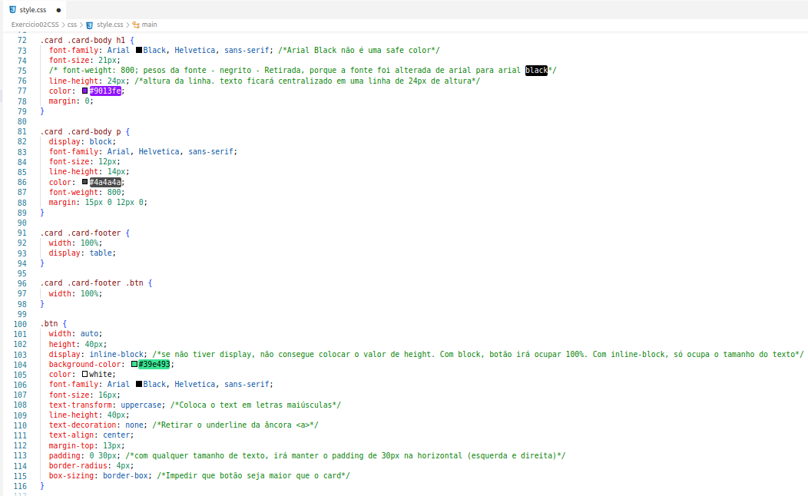

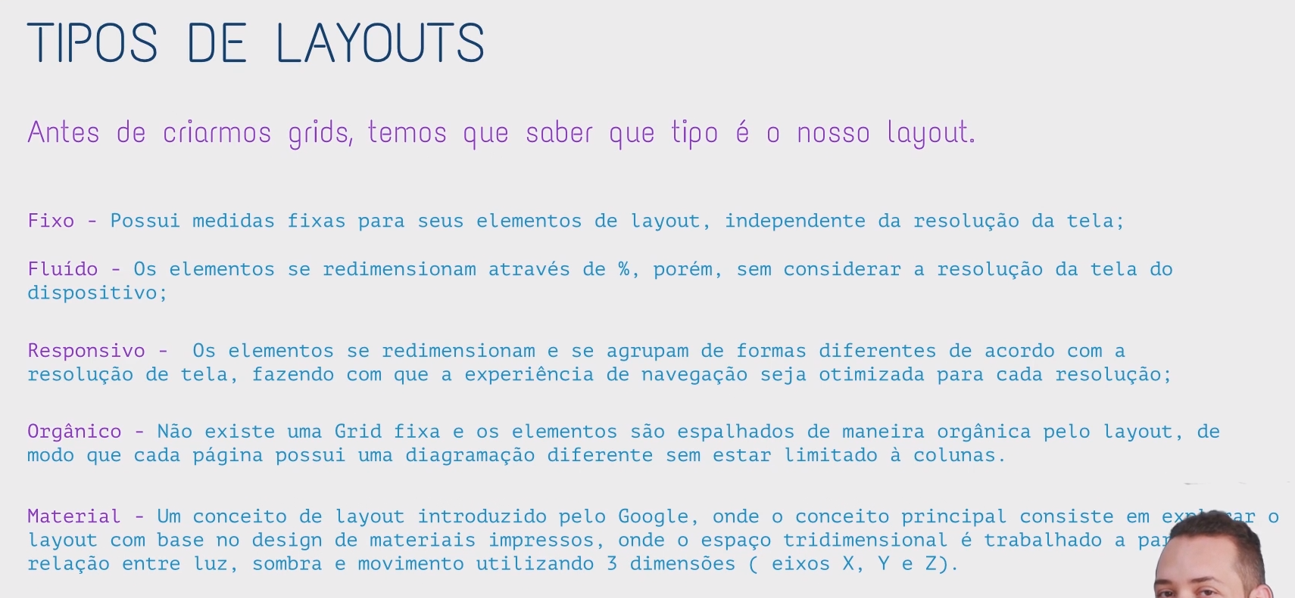

Design Responsivo;

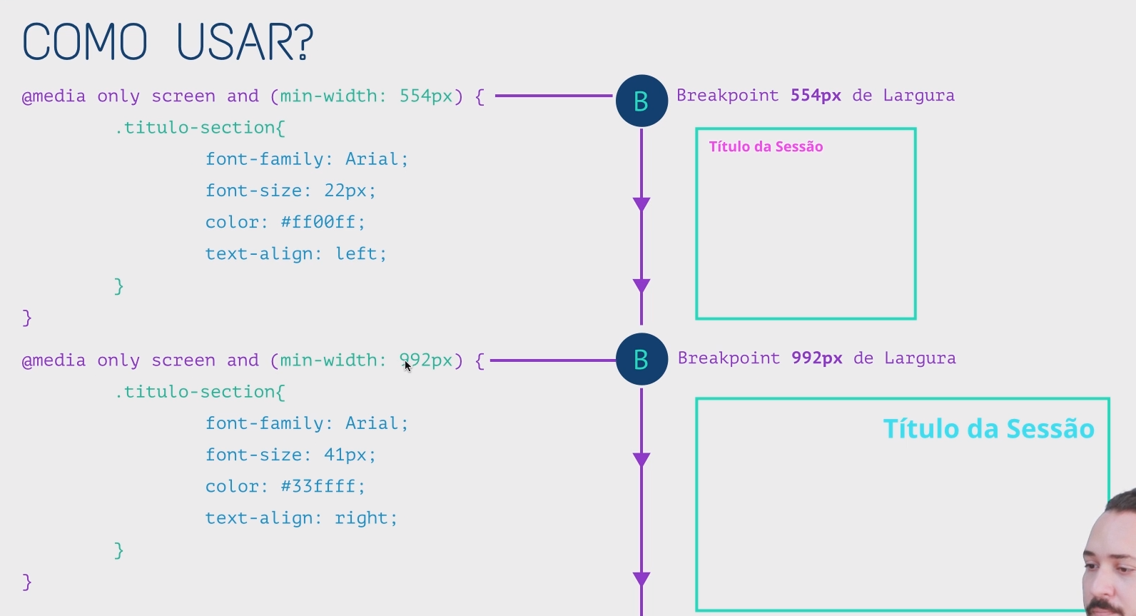

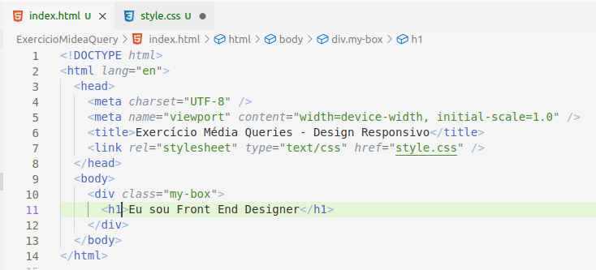

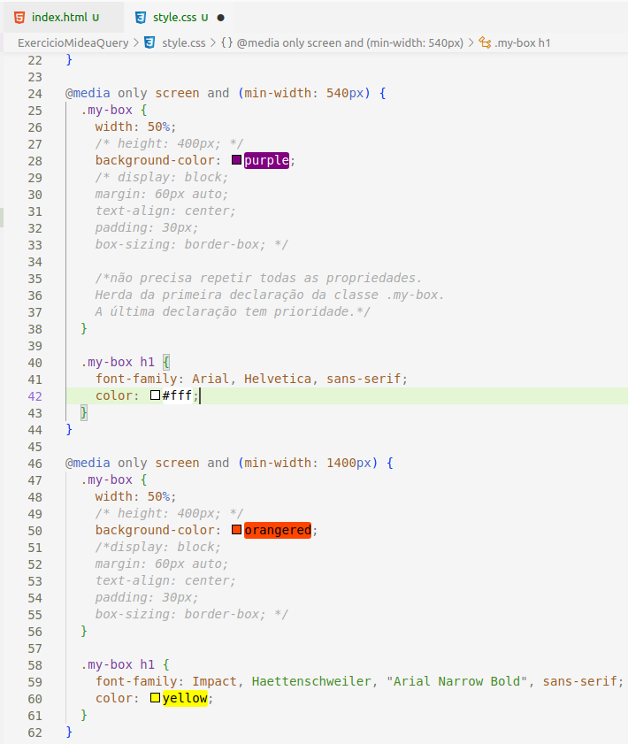

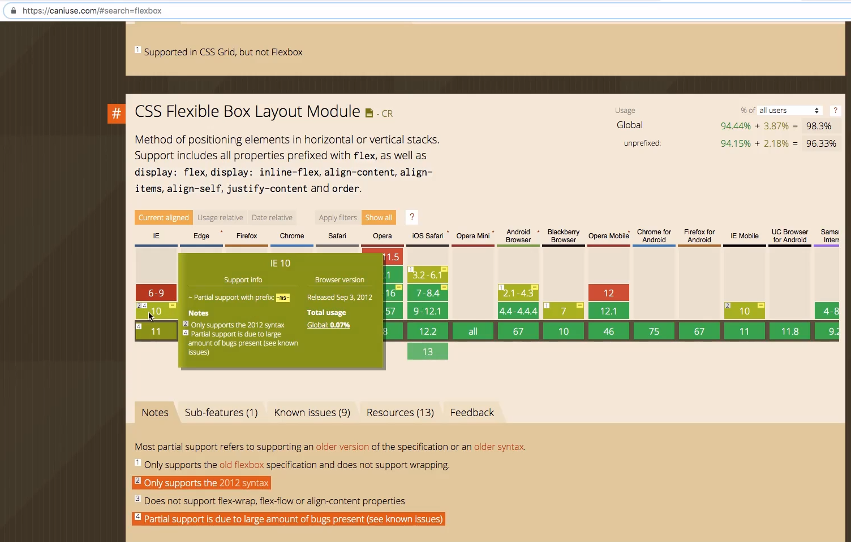

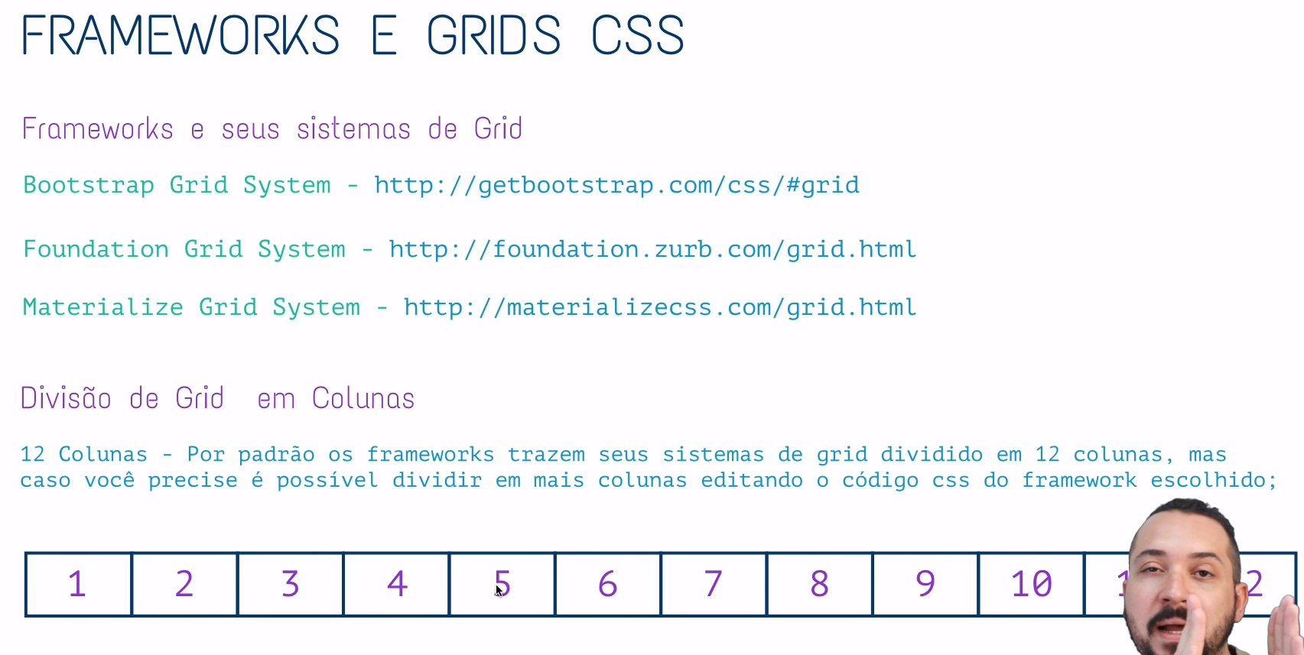

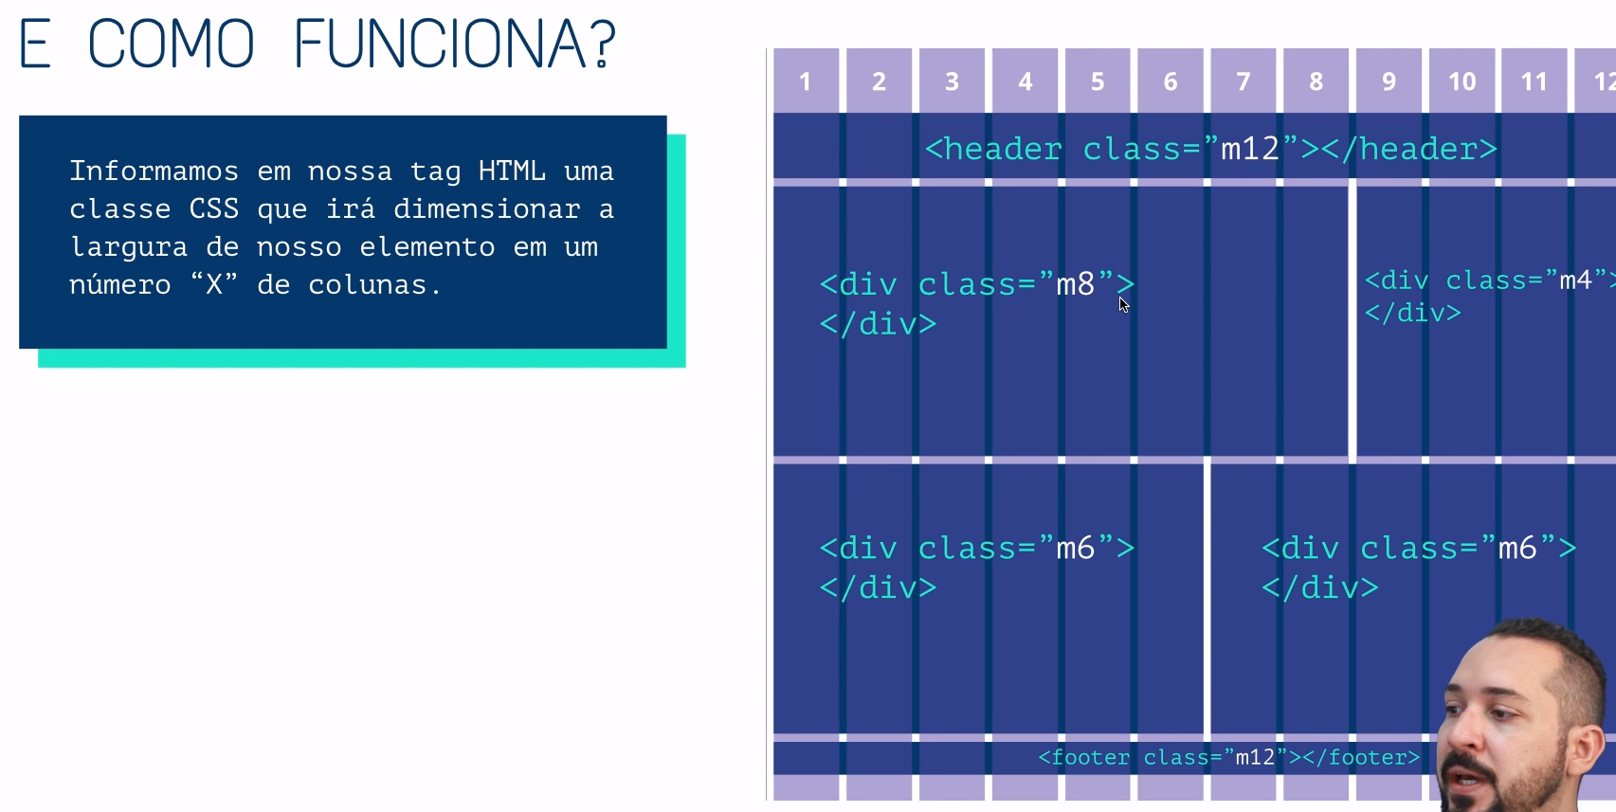

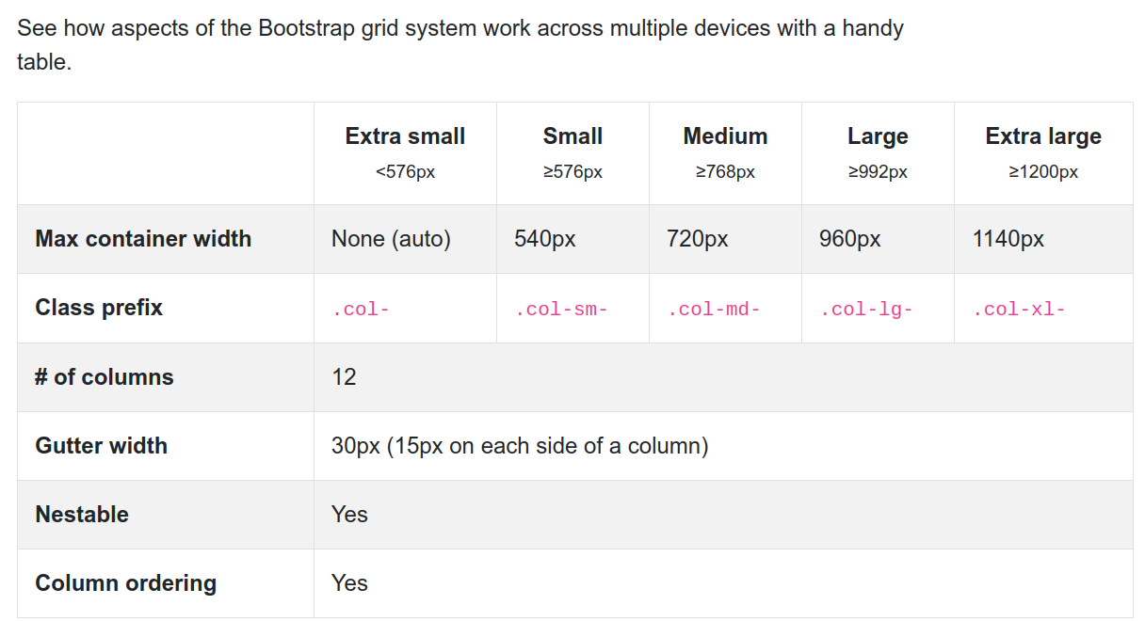

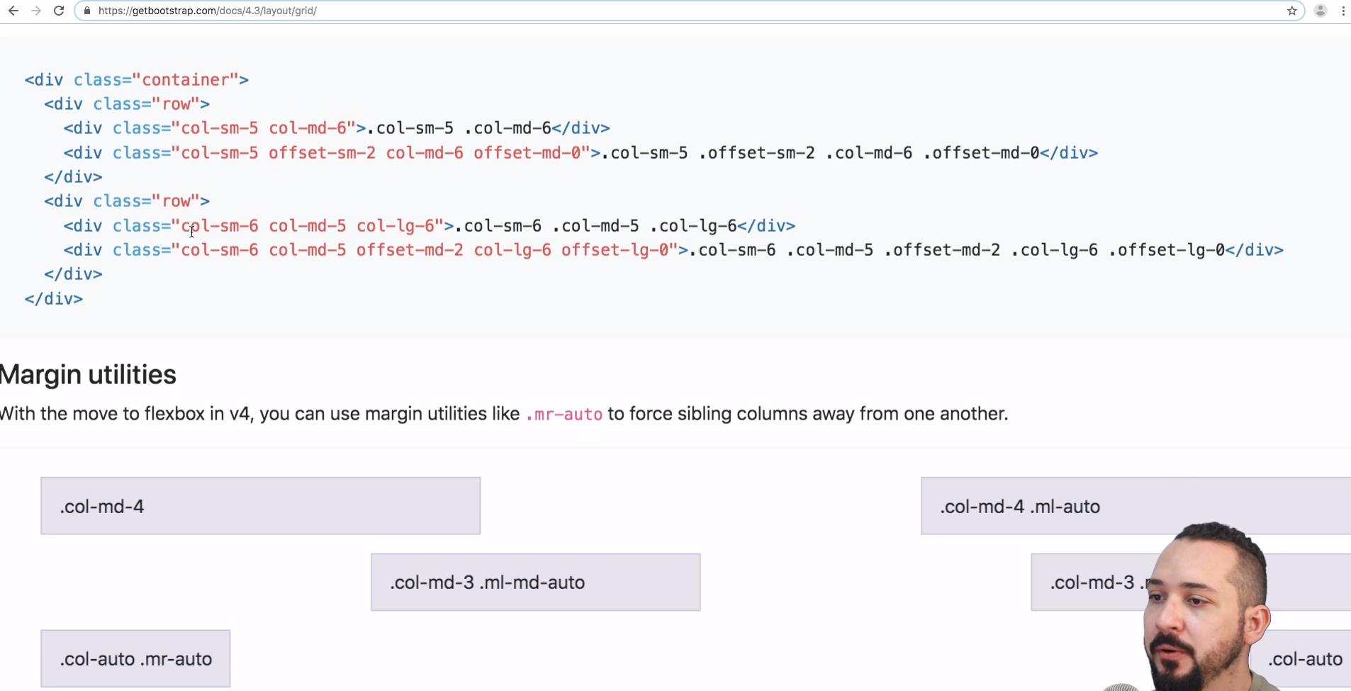

Baixar bootstrap-grid.min.css.

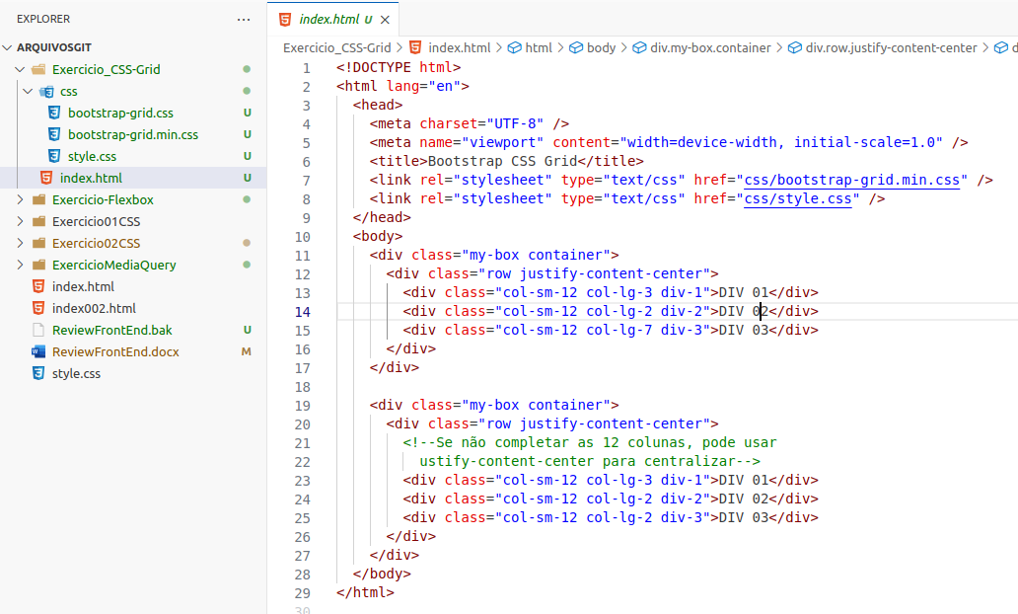

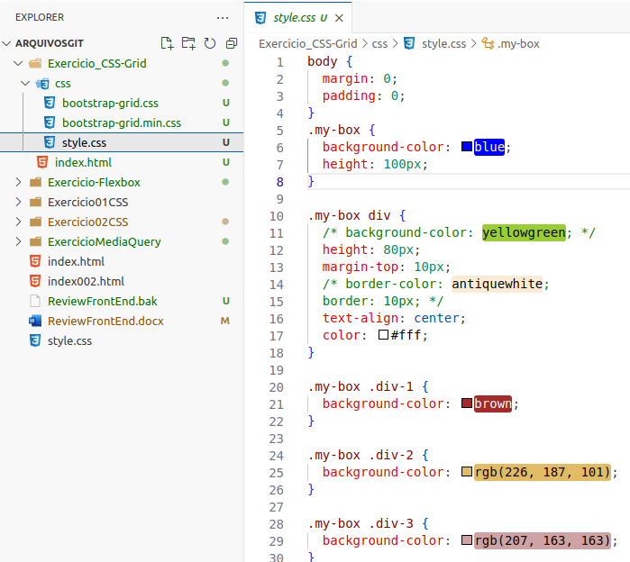

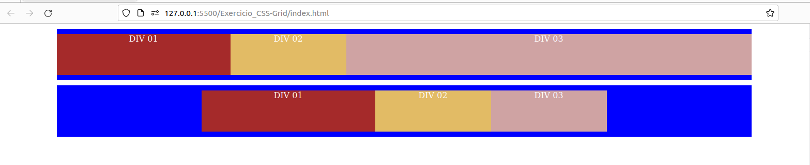

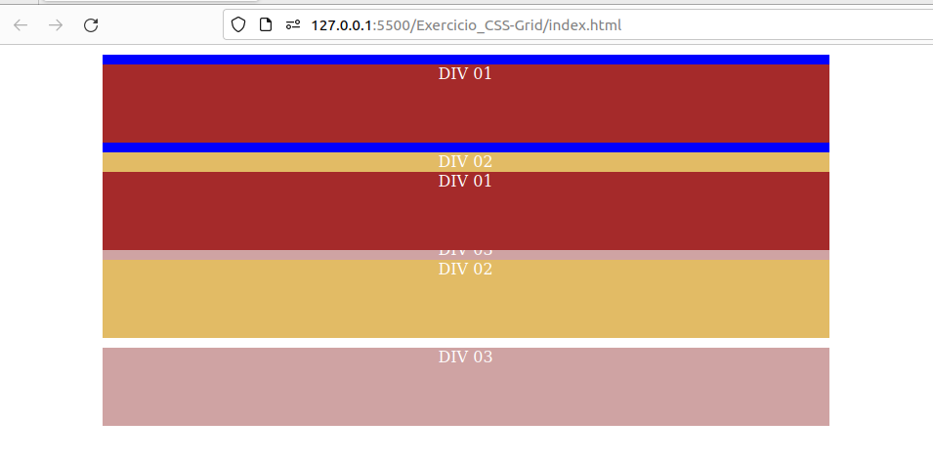

****************************************************************************************************************

[**https://css-tricks.com/snippets/css/a-guide-to-flexbox/#flexbox-background**](https://css-tricks.com/snippets/css/a-guide-to-flexbox/#flexbox-background)

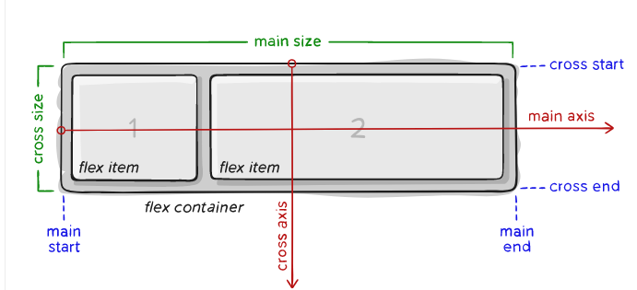

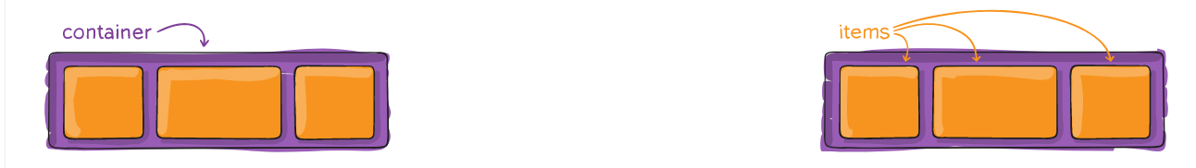

* **Main Axis depende da flex-direction**
* **se row então main axis = horizontal**
* **se column, então main axis = vertical**

****************************************************************************************************************

[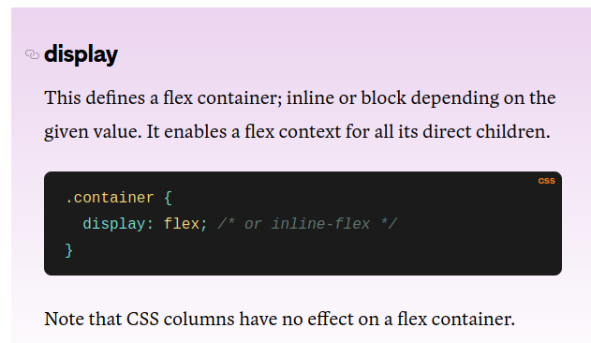](https://css-tricks.com/snippets/css/a-guide-to-flexbox/#flexbox-background)

***************************************************************************************************************

**flex-direction (eixo main-axis)**

[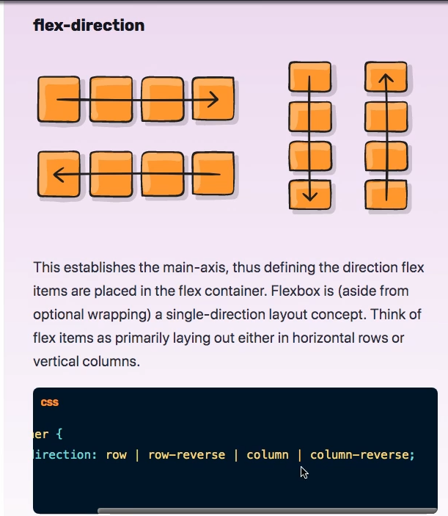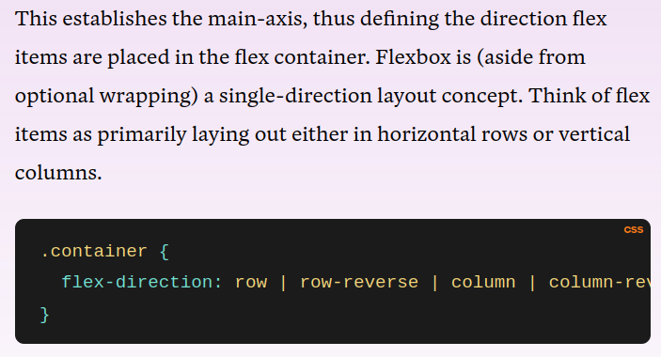](https://css-tricks.com/snippets/css/a-guide-to-flexbox/#flexbox-background)

[****************************************************************************************************************](https://css-tricks.com/snippets/css/a-guide-to-flexbox/#flexbox-background)

[**flex-wrap (tenta alocar em uma linha, senão quebra a linha)**](https://css-tricks.com/snippets/css/a-guide-to-flexbox/#flexbox-background)

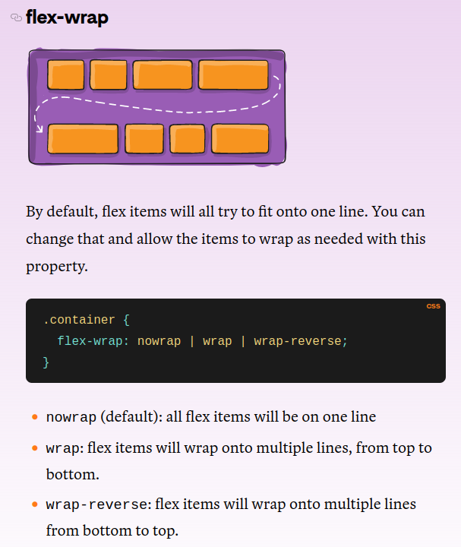

****************************************************************************************************************

**flex-flow --> permite informar a flex-direction e o flex wrap em um único comando**

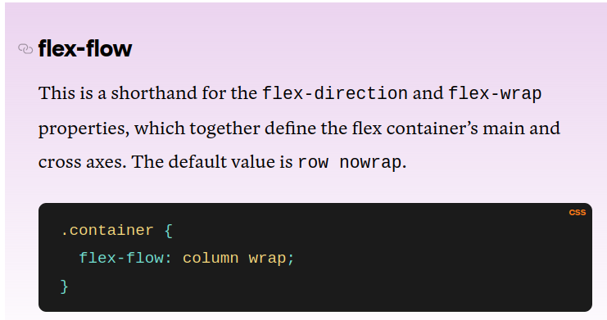

****************************************************************************************************************

**justify-content --> alinha main-axis**

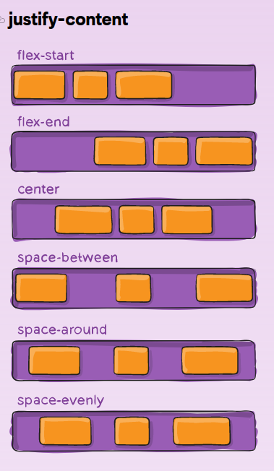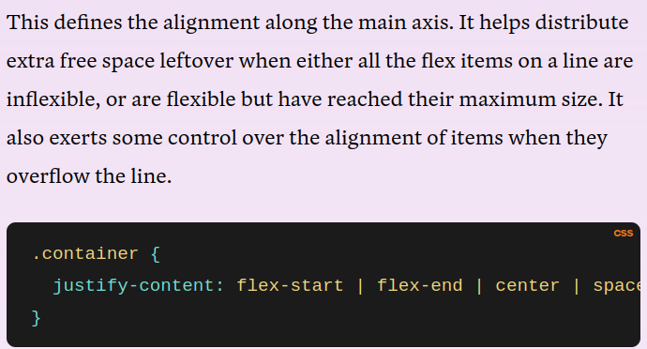

***************************************************************************************************************

**flex-basis: value; funciona de forma parecida com o width.**

****************************************************************************************************************

**align-items --> alinha o cross-axis**

**Baseline** alinha pelo texto que está dentro do elemento.

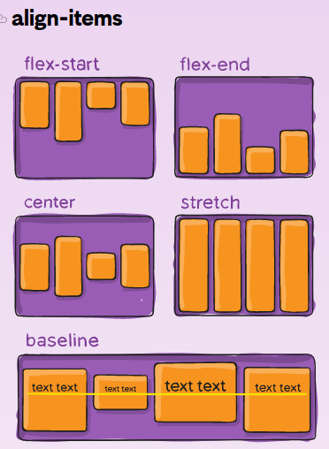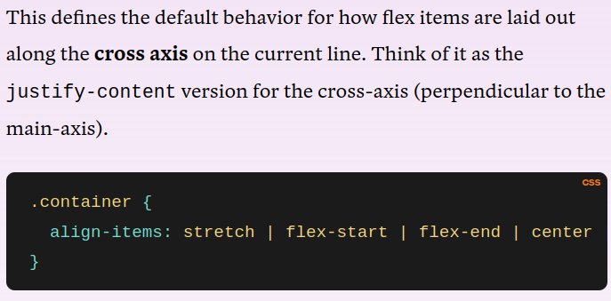

*******************************************************************************************

**align-context cross-axis**

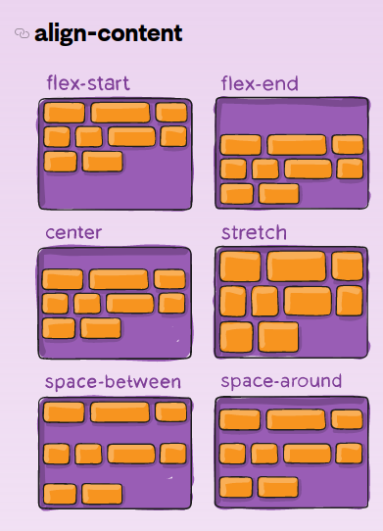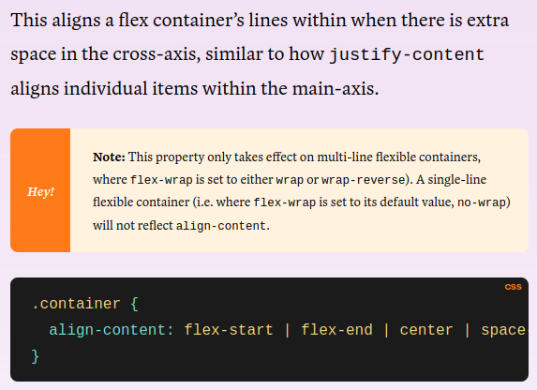

**********************************************************************************************

**ORDER**

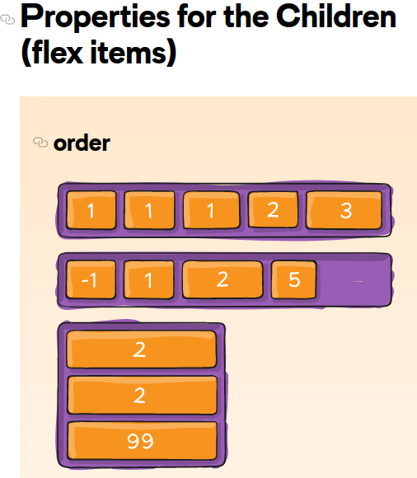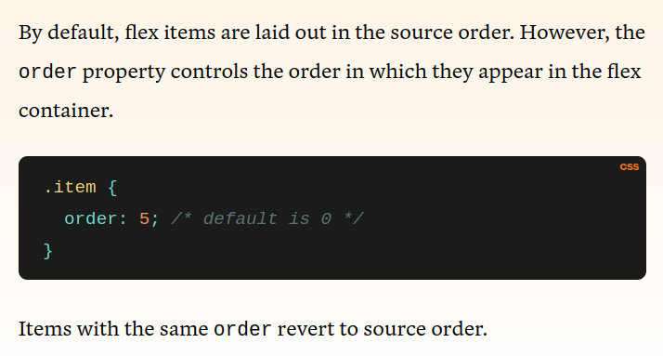

**se a ordem for a mesma para mais de um elemento, estes mantêm a ordem atual, entre eles**

**sem classe especificada, assume ordem 0 (primeira).**

**Ou seja, todos os elementos têm que ter uma ordem, senão o flexbox não saberá como ordená-los e manterá a ordem atual.**

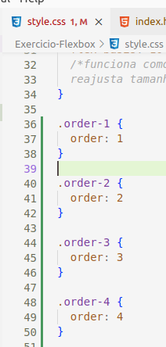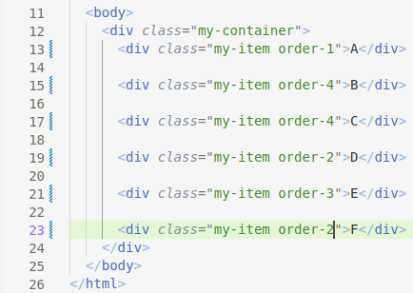

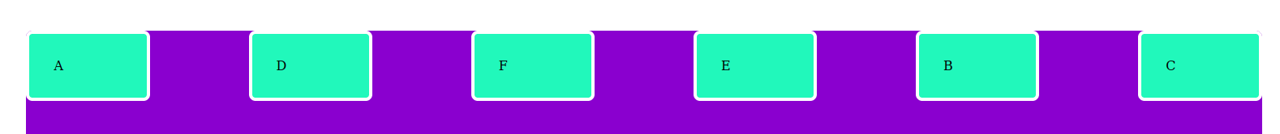

**\*\*\*\*\*\*\*\*\*\*\*\*\*\*\*\*\*\*\*\*\*\*\*\*\*\*\*\*\*\*\*\*\*\*\*\*\*\*\*\*\*\*\*\*\*\*\*\*\*\*\*\*\*\*\*\*\*\*\*\*\*\*\*\*\*\*\*\*\*\*\*\*\*\*\*\*\*\*\*\*\*\*\*\*\*\*\*\*\*\*\*\*\*\*\*\*\*\*\*\*\*\*\*\*\*\*\*\*\*\*\***

flex-grow

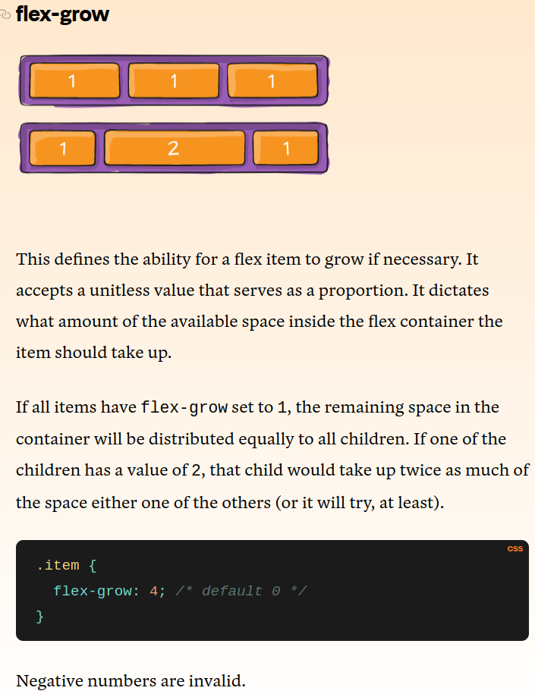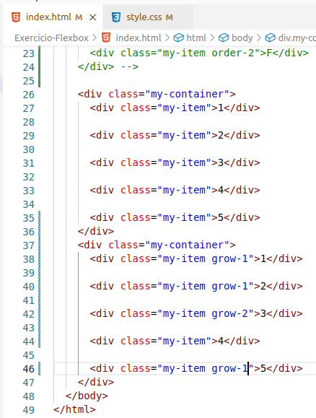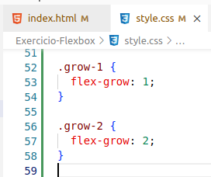

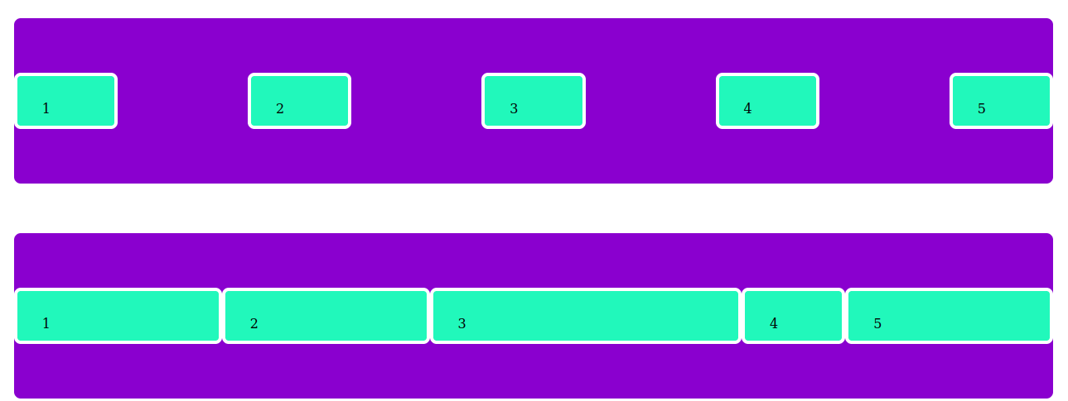

**\*\*\*\*\*\*\*\*\*\*\*\*\*\*\*\*\*\*\*\*\*\*\*\*\*\*\*\*\*\*\*\*\*\*\*\*\*\*\*\*\*\*\*\*\*\*\*\*\*\*\*\*\*\*\*\*\*\*\*\*\*\*\*\*\*\*\*\*\*\*\*\*\*\*\*\*\*\*\*\*\*\*\*\*\*\*\*\*\*\*\*\*\*\*\*\*\*\*\*\*\*\*\*\*\*\*\*\*\*\*\***

**flex-shrink**

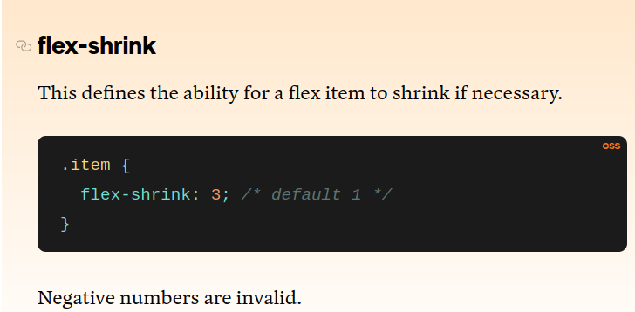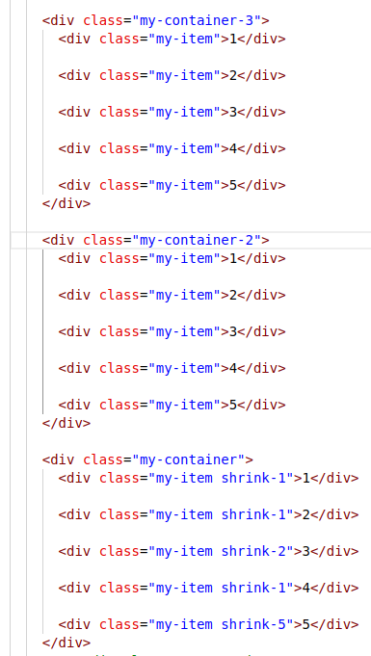

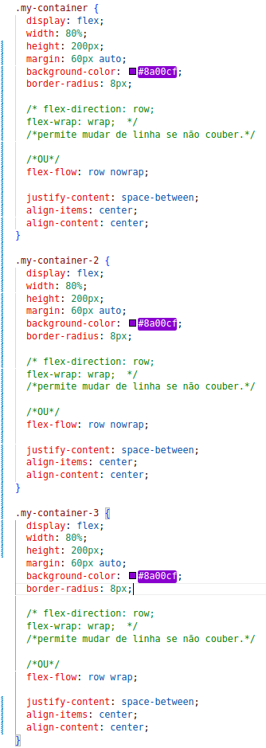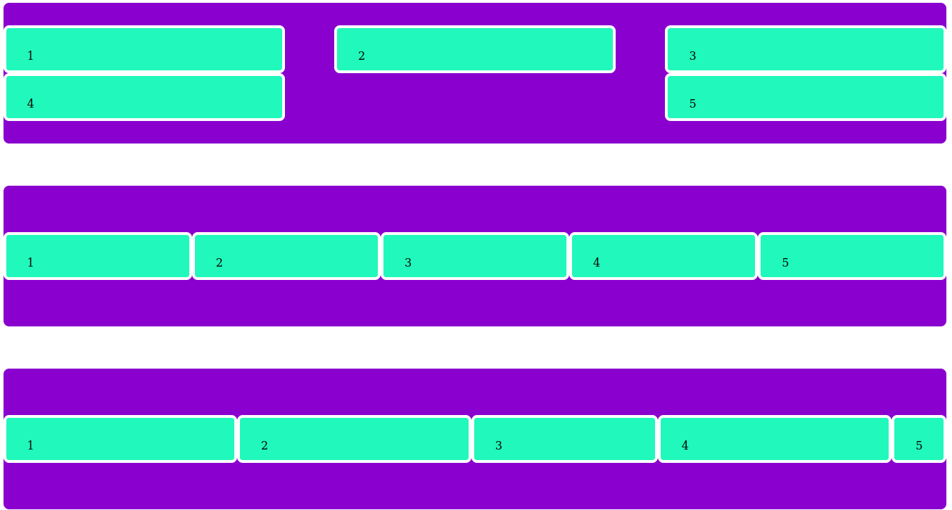

**nowrap --> wrap --> wrap com shrink**

**\*\*\*\*\*\*\*\*\*\*\*\*\*\*\*\*\*\*\*\*\*\*\*\*\*\*\*\*\*\*\*\*\*\*\*\*\*\*\*\*\*\*\*\*\*\*\*\*\*\*\*\*\*\*\*\*\*\*\*\*\*\*\*\*\*\*\*\*\*\*\*\*\*\*\*\*\*\*\*\*\*\*\*\*\*\*\*\*\*\*\*\*\*\*\*\*\*\*\*\*\*\*\*\*\*\*\*\*\*\*\***

**flex-basis**

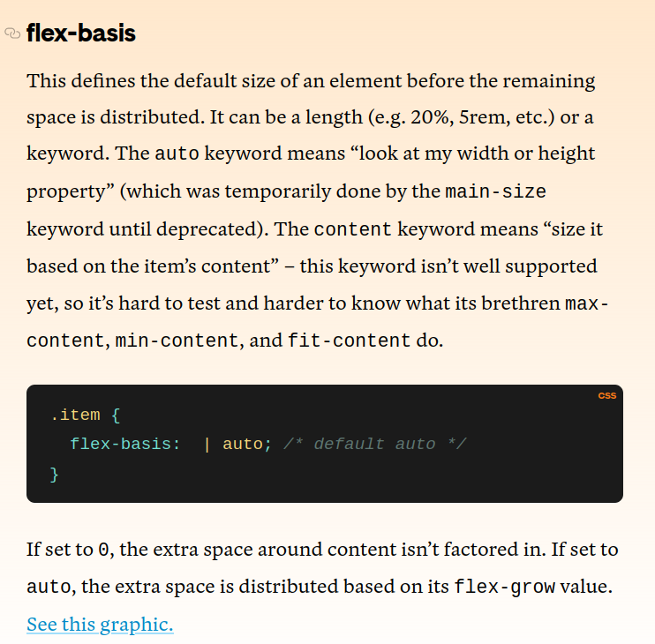

**\*\*\*\*\*\*\*\*\*\*\*\*\*\*\*\*\*\*\*\*\*\*\*\*\*\*\*\*\*\*\*\*\*\*\*\*\*\*\*\*\*\*\*\*\*\*\*\*\*\*\*\*\*\*\*\*\*\*\*\*\*\*\*\*\*\*\*\*\*\*\*\*\*\*\*\*\*\*\*\*\*\*\*\*\*\*\*\*\*\*\*\*\*\*\*\*\*\*\*\*\*\*\*\*\*\*\*\*\***

**Ótima referência para CSS:**

[**https://developer.mozilla.org/en-US/docs/Web/CSS/flex-direction**](https://developer.mozilla.org/en-US/docs/Web/CSS/flex-direction)

**\*\*\*\*\*\*\*\*\*\*\*\*\*\*\*\*\*\*\*\*\*\*\*\*\*\*\*\*\*\*\*\*\*\*\*\*\*\*\*\*\*\*\*\*\*\*\*\*\*\*\*\*\*\*\*\*\*\*\*\*\*\*\*\*\*\*\*\*\***

**flex**

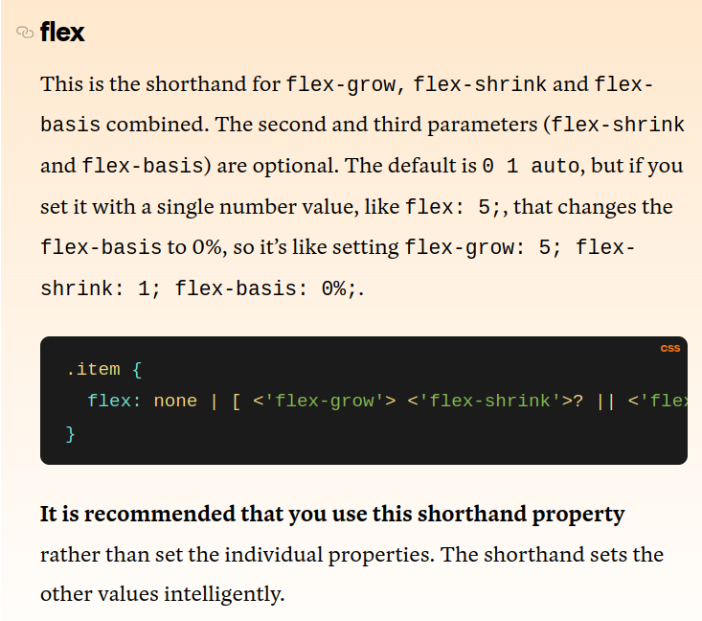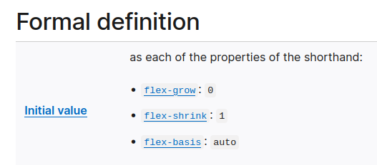

**\*\*\*\*\*\*\*\*\*\*\*\*\*\*\*\*\*\*\*\*\*\*\*\*\*\*\*\*\*\*\*\*\*\*\*\*\*\*\*\*\*\*\*\*\*\*\*\*\*\*\*\*\*\*\*\*\*\*\*\*\*\*\*\*\*\*\*\*\***

**align-self**

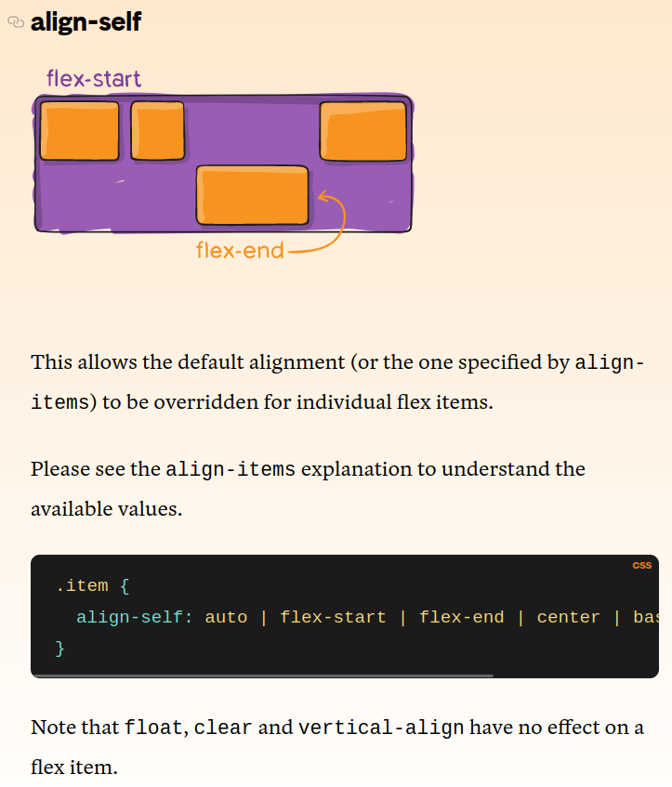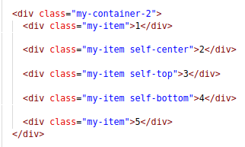

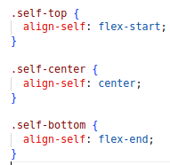

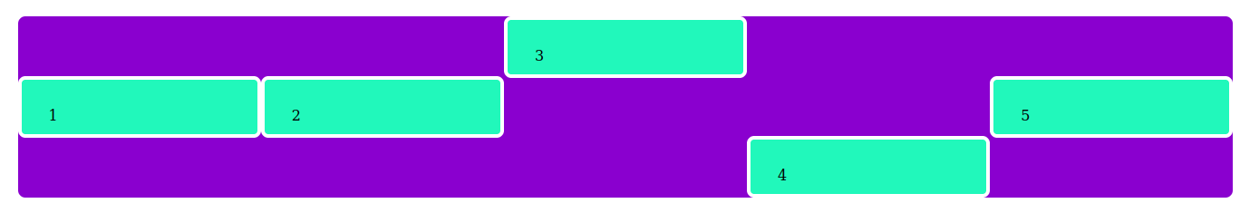

**\*\*\*\*\*\*\*\*\*\*\*\*\*\*\*\*\*\*\*\*\*\*\*\*\*\*\*\*\*\*\*\*\*\*\*\*\*\*\*\*\*\*\*\*\*\*\*\*\*\*\*\*\*\*\*\*\*\*\*\*\*\*\*\*\*\*\*\***

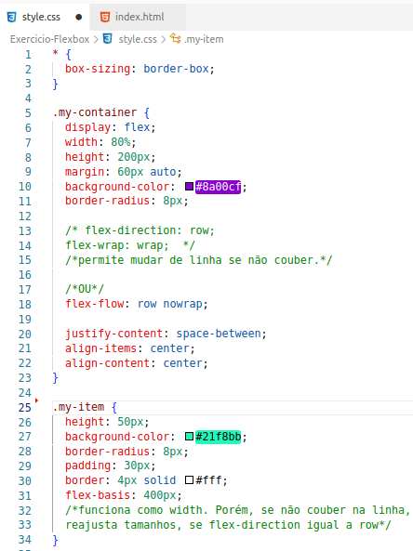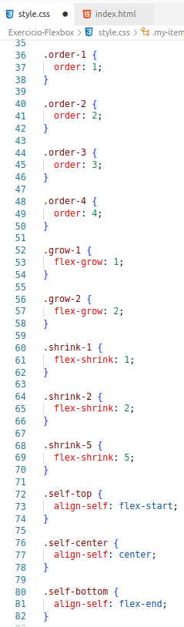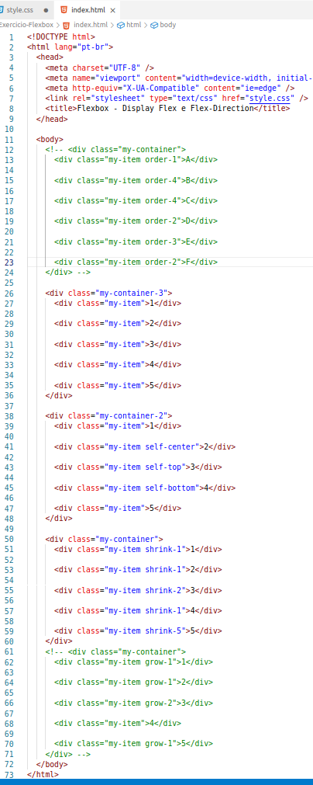

**\*\*\*\*\*\*\*\*\*\*\*\*\*\*\*\*\*\*\*\*\*\*\*\*\*\*\*\*\*\*\*\*\*\*\*\*\*\*\*\*\*\*\*\*\*\*\*\*\*\*\*\*\*\*\*\*\*\*\*\*\*\*\*\*\*\*\*\*\***

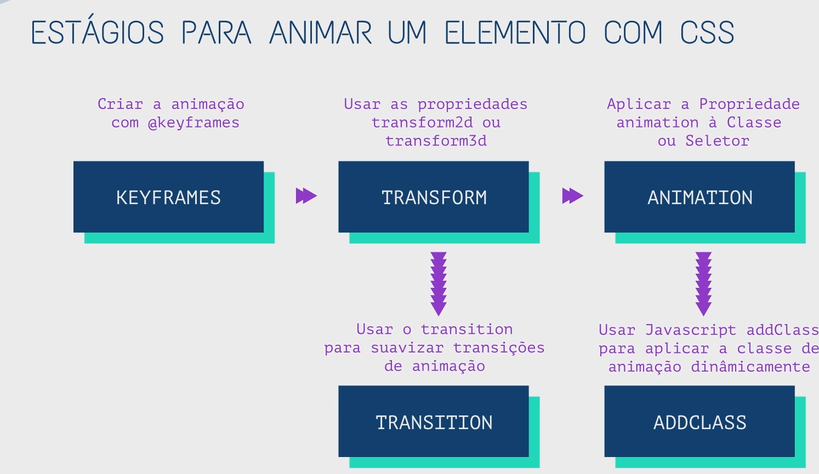

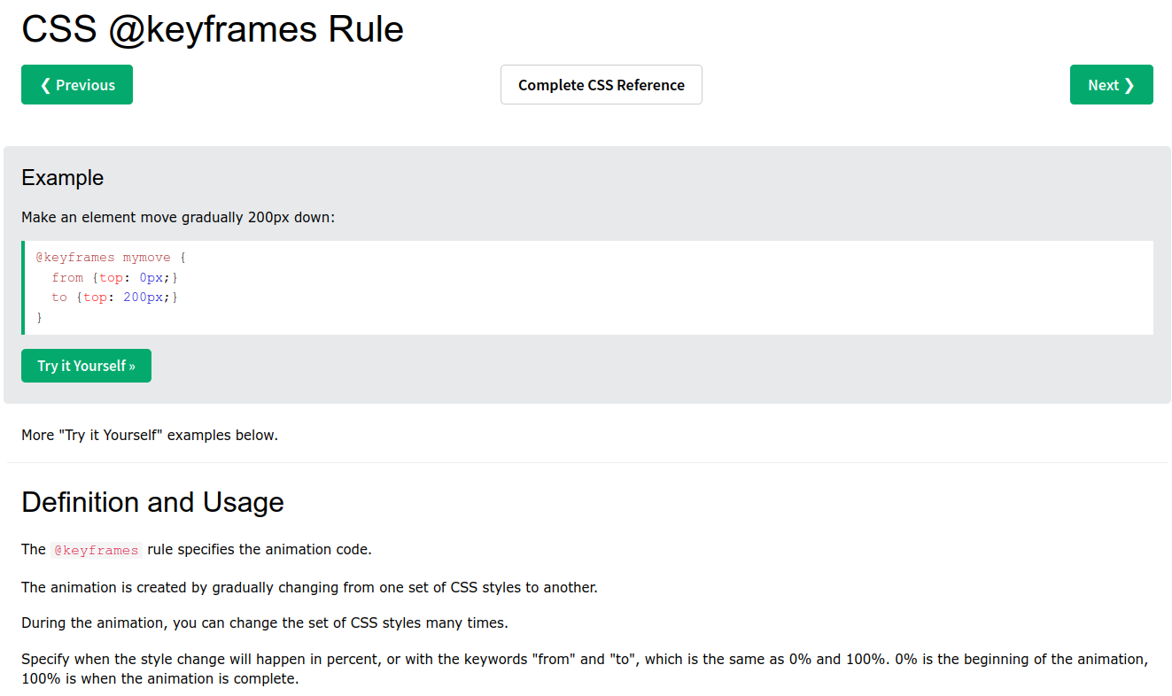

[**https://www.w3schools.com/cssref/css3_pr_animation-keyframes.php**](https://www.w3schools.com/cssref/css3_pr_animation-keyframes.php)

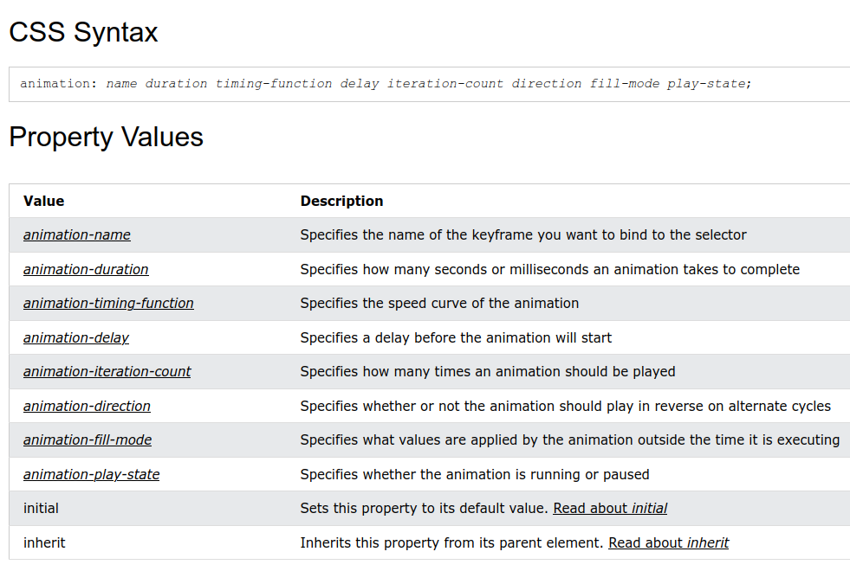

div {  
 animation-name: example;  
  animation-duration: 5s;  
  animation-timing-function: linear;  
  animation-delay: 2s;  
  animation-iteration-count: infinite;  
  animation-direction: alternate;  
 }

div {  
 width: 100px;  
 height: 100px;  
  background: red;  
  position: relative;  
  animation-name: example;  
 animation-duration: 3s;  
  animation-fill-mode: forwards;  
 }

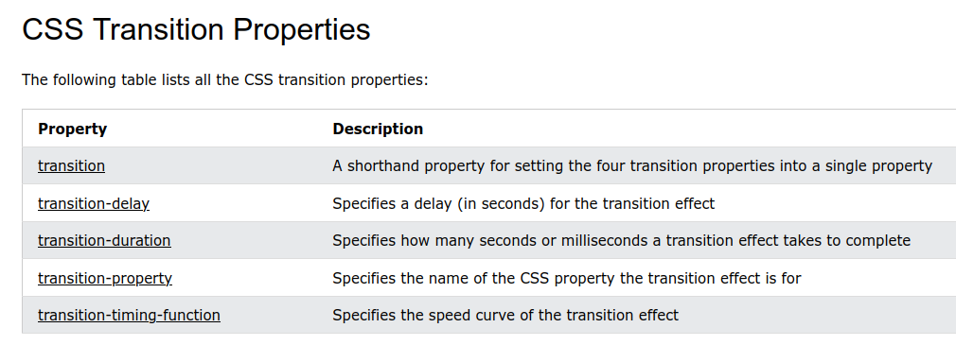

div {  
 width: 100px;  
  height: 100px;  
 background: red;  
  transition: width 2s;  
 }

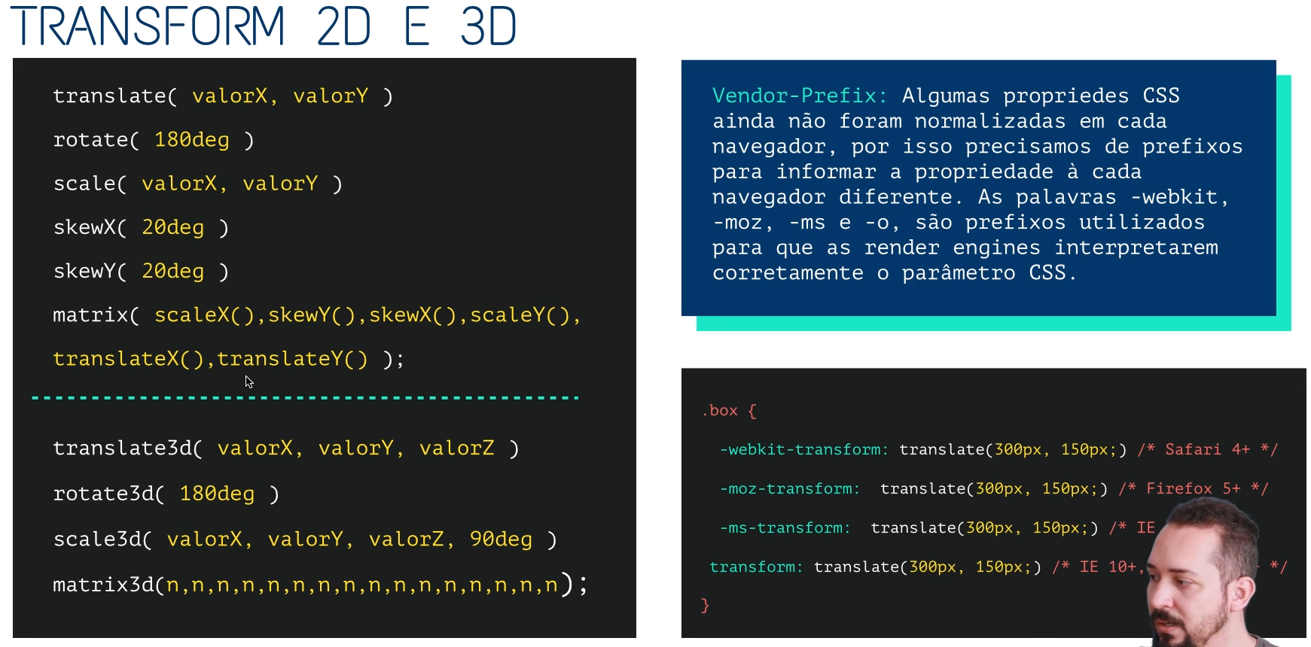

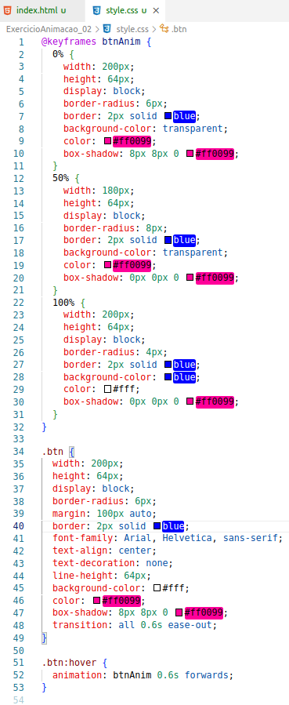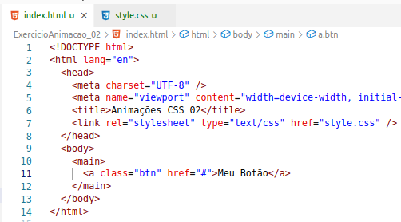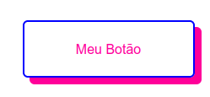

****************************************************************************************************************

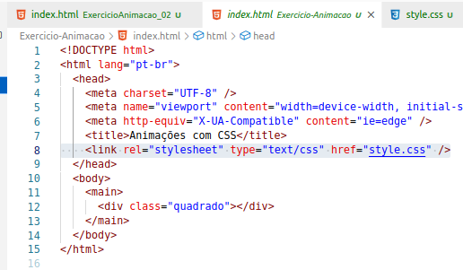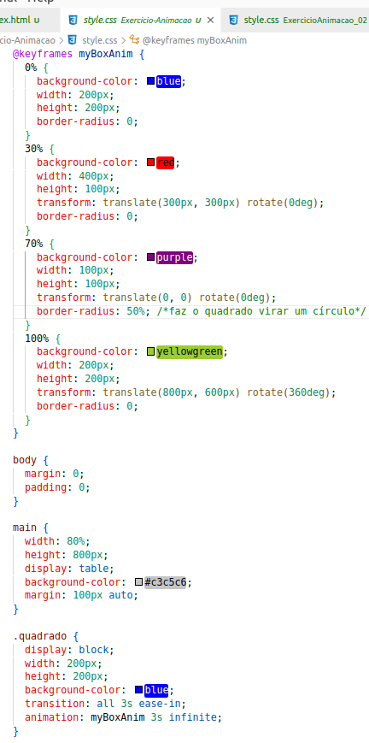

**************************************************************************************************************

[**https://github.com/animate-css/animate.css/releases/tag/3.7.0**](https://github.com/animate-css/animate.css/releases/tag/3.7.0)



<https://animate.style/>

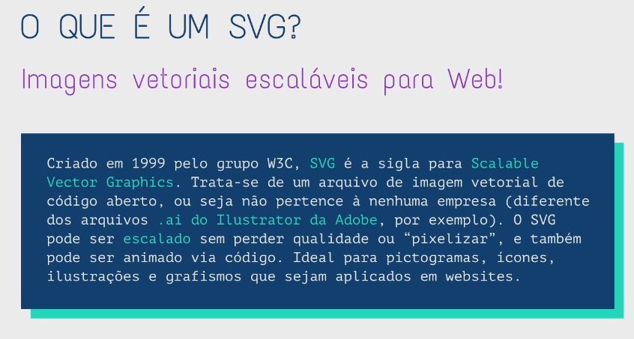

<https://developer.mozilla.org/pt-BR/docs/Web/SVG>

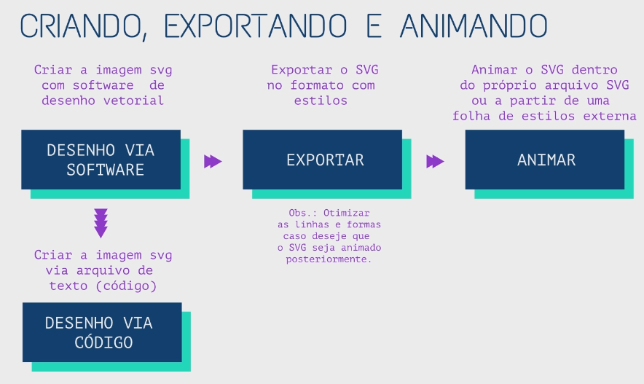

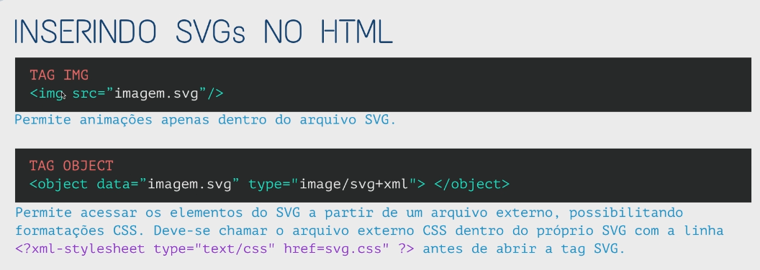

**Arquivos Figma**

Ao longo do curso eu utilizarei alguns Designs que criei no Figma. Seguem os links dos designs para que você possa acompanhar as aulas:

**Exercício CSS Grid (Modernista):**https://www.figma.com/file/cGbhXoUjTri2HFCYPONzai/Exercicio-CSS-Grid---Front-End-Design-Avan%C3%A7ado---Codesigners?type=design&node-id=0%3A1&t=YsQ4Yavd3pFWZKP9-1

**Exercício CSS Grid (Masonry):**https://www.figma.com/file/QgG2e43t8Eyc0uXkvrj7l4/Exerc%C3%ADcio-CSS-Grid-02?type=design&node-id=0%3A1&t=BB8i5ebNgzGTNKrj-1

**CSS Modules:**https://www.figma.com/file/9tcijDzoSZeiM73EVRwEw0/CSS-Avan%C3%A7ado---CSS-Modules?type=design&node-id=0%3A1&t=0ZveyTb1Wk5FQaBC-1

**********************************************************************************************************************************

Box-model

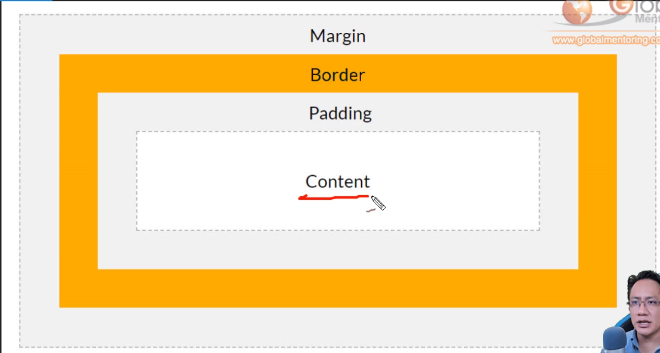

**********************************************************************************************************************************

Display block (block é default para h1, div, p, li, ...)

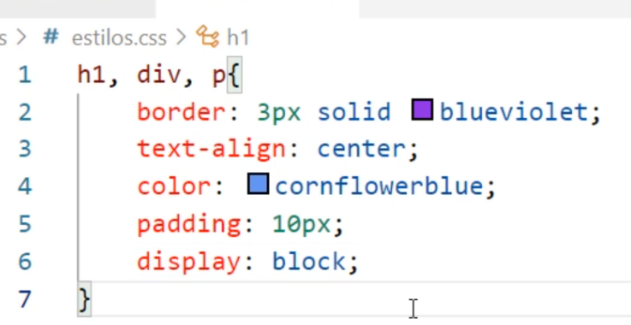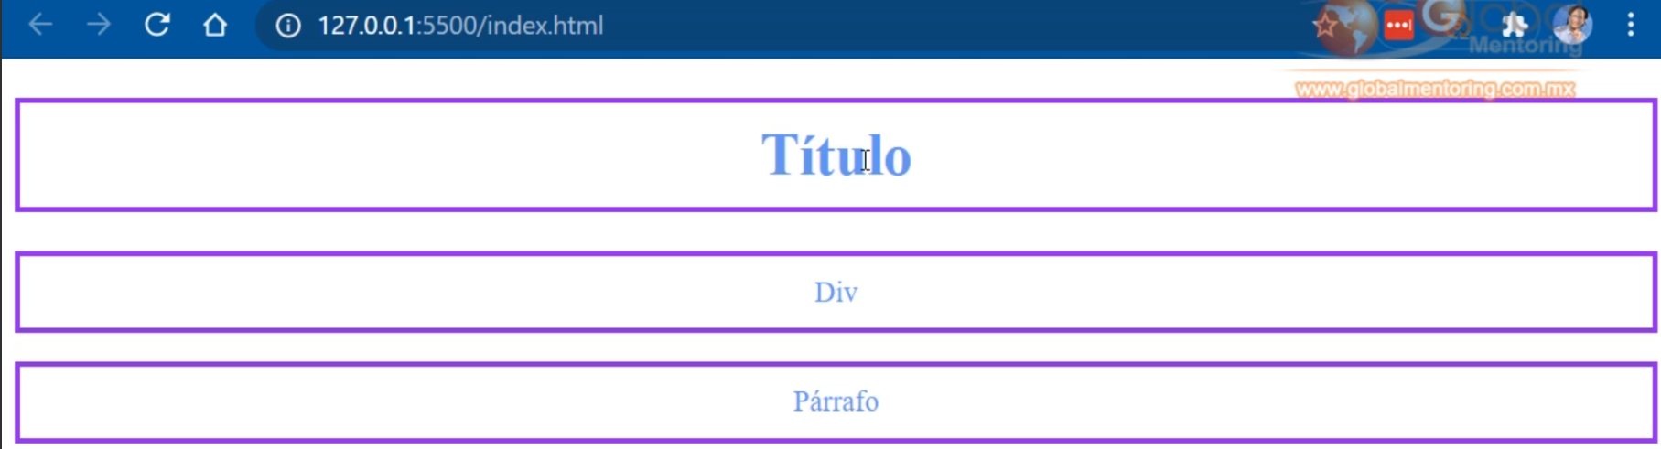

*********************************************************************************************************************************

Display inline (valor default para span, link, img, ...)

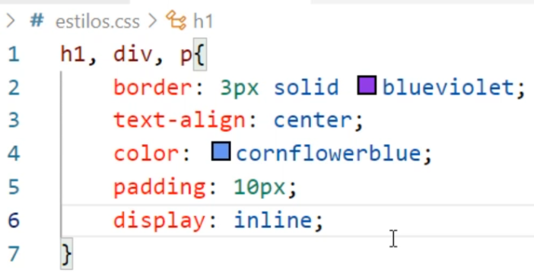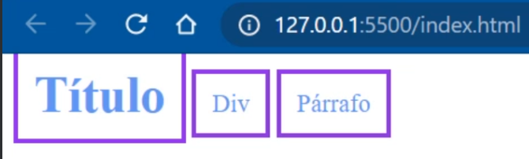

**********************************************************************************************************************************



<https://css-tricks.com/snippets/css/css-grid-starter-layouts/>

<https://ninjarockstar.dev/css-hex-grids>

<https://randomuser.me/>

A free, [open-source](https://github.com/RandomAPI/Randomuser.me-Node) API for generating random user data. Like Lorem Ipsum, but for people.

<https://magicpattern.design/tools/css-backgrounds>

<https://undraw.co>

<https://manypixels.co/gallery>

<https://lukaszadam.com/illustrations>

<https://css-tricks.com/snippets/css/complete-guide-grid/>